MODEL REPLACEMENT OF MARBLE AS AGGREGATES IN CONCRETE

₁S.KIRAN, ² K.PRANAV, ³ M.MOUNIKA,⁴ K SAI
^{1,2,3,4} Dept of Civil Engineering, Malla Reddy Engineering College And Management Sciences, Kistapur, Medchal.

ABSTRACT –

Today we are looked with an essential utilization and a developing requirement for totals in light of the fact that of the development in modern generation, this circumstance has prompted a quick reduction of accessible assets. Then again, a high volume of marble creation has produced a lot of waste materials; right around 70% of this mineral gets squandered in the mining, handling and cleaning stages which seriously affect nature. The handling waste is dumped and debilitating the aquifer. Thusly, it has turned out to be important to reuse these squanders especially in the fabricate of solid items for development purposes. The principle objective of this examination is to show the likelihood of utilizing marble squanders as a substitute instead of normal totals in solid creation. The paper introduces the examination procedure, the portrayal of waste marble totals and different pragmatic definitions of cement. This trial examination was completed on three arrangement of solid blends: Fine total substitution blend and course total substitution blend .The solid plans were created with a steady water/bond proportion.

- INTRODUCTION
Today we are looked with a basic usage and a creating necessity for sums in light of the way that of the improvement in present day age, this situation has incited a fast lessening of open resources. On the other hand, a high volume of marble creation has delivered a considerable measure of waste materials; ideal around 70% of this mineral gets misused in the mining, taking care of and cleaning stages which truly influence nature. The taking care of waste is dumped and incapacitating the aquifer. Subsequently, it has ended up being critical to reuse these misuses particularly in the create of strong things for improvement purposes. The rule target of this examination is to demonstrate the probability of using marble misuses as a substitute rather than typical aggregates in strong creation. The paper presents the examination strategy, the depiction of waste marble aggregates and distinctive practical meanings of concrete. This trial examination was finished on three game plan of strong mixes: Fine aggregate substitution mix and course add up to substitution mix .The strong plans were made with a consistent water/bond extent” material.
OBJECTIVES OF THE STUDY
The key goal of this work was to create solid blends, utilizing marble squander as a halfway substitution for typical granitic totals and fine totals, which display satisfactory properties equivalent to that of auxiliary coarse totals and fine totals.
- To consider the impact of utilization of waste marble tidy on the mechanical properties of cement.
- To think about the impact of utilization of waste marble totals on the mechanical properties of cement.
- To look at the compressive quality utilizing marble items with the given outline blend.
- To set up elective for sand and course total with halfway utilization of marble
squanders in concrete.
RESEARCH HYPOTHISIS
Marble chips might be appropriately utilized as an option (halfway substitution) to ordinary granitic totals in basic cement and Marble tidy powder might be reasonably utilized as an option (incomplete substitution) to typical fine totals in auxiliary cement.
SCOPE OF THE STUDY
In solid blend outline, it is important to dissect tentatively and for all intents and purposes every one of the parts of the solid blend i.e. Bond, totals, added substances and water. Because of the restricted time accessible, it wasn‟t conceivable to explore the properties of the previously mentioned parts. Long haul conduct investigation of marble total solid use in fortified cement under climate introduction was likewise unrealistic because of time limitations. In this task, 43 review OPC was utilized accepting its properties hold for different sorts of bond. The examination will be significantly managing the investigation of the properties of marble squander chips and marble tidies to be utilized as coarse totals and fine totals in concrete. Preceding creating blend outlines, evaluating was done to get the required molecule measure
dissemination and tests were performed to describe the total. The compressive qualities at 14 and 28 days of curing of solid 3D squares will be investigated. For CA substitution six trial blends were readied, to be specific;
- Normal mix (control) i.e. cement + water + FA + coarse aggregate (granitic).
- Special mix 1 i.e. cement + water + FA+ blended

- coarse aggregate (5% marble waste chips + 95% normal CA)
- Special mix 2 i.e. cement + water + FA + blended
- coarse aggregate (10% marble waste chips + 90% normal CA )
- Special mix 3 i.e. cement + water + FA + blended
- coarse aggregate (15% marble waste chips + 85% normal CA)
- Special mix 4 i.e. cement + water + FA + blended
- coarse aggregate (20% marble waste chips + 80% normal CA)
- Special mix 5 i.e. cement + water + FA + blended
- coarse aggregate (50% marble waste chips + 50% normal CA)
Similarly for fine aggregate replacement five trial mixes were prepared, namely

- Special mix 1 i.e. cement + water + CA + blended fine aggregate (5% marble dust + 95% normal FA)
- Special mix 2 i.e. cement + water + CA+ blended fine
- aggregate (10% marble dust + 90% normal FA )
- Special mix 3 i.e. cement + water + CA + blended fine aggregate (15% marble dust + 85% normal FA)
- Special mix 4 i.e. cement + water + CA + blended fine aggregate (20% marble dust + 80% normal FA)
- Special mix 5 i.e. cement + water + CA + blended fine aggregate (50% marble dust + 50% normal FA)

- LITERATURE REVIEW
Nutan Patel et al. examined on Marble Waste: Opportunities for Development of Low Cost Concrete. The creator considered Based on the Indian Standard (IS: 10262-1982), outline blend for M30 review of cement was set up by mostly supplanting fine total with five distinct
rates by weight of marble powder (0%, 5%, 10%, 15%, and 20%).There is a slight lessening in compressive quality esteem solid blend when 20% marble powder is utilized as contrasted and that of 15% marble powder blend. Compressive quality of the solid has expanded with expanding rates of marble tidy augmentations. The creator conclusion for this exploration rate of the 0% marble squander 28 days quality is 38 N/mm2 at this quality of solid rate is Rs. 3760.25. Subsequent to including the marble clean expands the quality. The most noteworthy compressive quality has been exhibited by 15% marble clean is 40.5 N/mm2 at this quality of solid rate is Rs. 3732.56. By utilizing the marble tidy the rate of the solid is abatement and quality is increment. Shirule, P.A et al .examined Partial supplanting of bond with marble clean powderin this paper creator ponders 30 3D shapes and 30 barrels have been threw. The compressive quality and split elasticity of 3D squares and barrels was estimated for 7 and 28 days and bond utilized is 53 review. M20 review with ostensible blend 1:1.5:3 according to IS 456-2000 was utilized and a water bond proportion of 0.5. Marble powder were included cement in venture of 5% (0%, 5%, 10%, 15%, 20% ).this paper finished up by the creator quality of cement has been tried on barrel at 7 days curing and 28 days. 7days test has been directed to check the pick up in beginning quality of cement. 28 days test gives the information of conclusive quality of cement at 28 days curing. At 10% utilization of marble squander in concrete there is 27.4% expansion in starting compressive quality. Up to 10% substitution of marble squander there is increment of compressive quality and split rigidity. Ali A. Aliabdo et al.:studied on the Re-utilization of waste marble tidy in the generation of bond and cement. The creator ponder in paper the properties of cement contained marble clean as a bond substitution and as a sand substitution. The substitution proportions which have been contemplated
were 0.0%, 5.0%, 7.5%, 10.0% and 15% by weight. Water to powder proportion (w/p) or water to concrete proportion (w/c) were 0.50 and 0.40 if there should arise an occurrence of bond substitution and in the event of sand substitution individually. This paper finished up by in concrete compressive quality increments with the expansion of marble tidy proportion as sand substitution up to 15.0% of sand by weight. 0.4 w/c proportion utilization of substitution marble tidy in concrete substance of somewhat increment comp. strength.0.4 w/c proportion utilization of substitution of marble tidy in concrete substance for 10% in most extreme split rigidity and 0.5 w/c proportion in7.5% trade marble tidy for maximumsplit elasticity Maximum bond quality of steel – concrete recorded with 10% substitution of marble tidy in bond or sand both w/c condition

Fine Aggregate | 693
Course Aggregate | 1104
Water | 209

METHODOLOGY
Methodology flowchart for determining optimum Contents of theM₂₀ concrete.
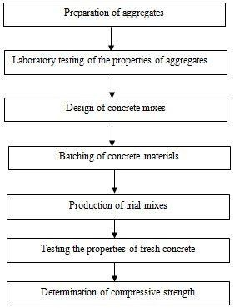
Batching of concrete materials by weight may

be expressed as follows
Wt. (C) + Wt. (CA) + Wt. (FA) + Wt. (Air) = Wt. (CC)
Where,
Wt (C) = Weight of cement
Wt (CA) = Weight of coarse aggregate Wt (FA) = Weight of fine aggregate Wt (Air) = Weight of entrained air
Wt (CC) = Weight of compacted concrete

Trial Mix
According to the blend plan, the solid is blended and the droop test is directed. Be that as it may, for the principal blend we couldn't get the coveted droop, i.e.75mm. So we overhauled the blend by keeping the water concrete proportion consistent and by expanding the water content by 3% the blend is upgraded. The blend did not give the coveted droop. The strategy is proceeded till the coveted droop is gotten. A water substance of 9% gave the required droop. Consequently, the aggregate amount of materials required for 1m3 of cement

Materials | Quantity in kg/m³
Cement | 380

FIXING THE DESIRED MIX PROPORTION AND CASTING THE SPECIMENS
M20 solid blend proportioning tests led following the IS code yielded a blend extent of 1:1.72:2.85 for bond, sand and coarse totals with a W/C proportion of Six distinctive blends specifically MC-5, MC-10, MC-15, MC-20, MC-50, were readied using Marble chip as a coarse total substitution material. The example number speaks to the marble chip substitution level of coarse total. Eighteen 3D square examples including 3

ostensible blends of 150 x 150 x 150 mm were thrown.
Likewise, the same procedure has been done for the fine aggregate replacement in the M20 concrete. M20 concrete mix proportioning experiments conducted following the IS code yielded a mix proportion of 1:1.72:2.85 for cement, sand and coarse aggregates with a W/C ratio of 0.55. Six different mixes namely MD-5, MD-10, MD-15, MD-20, MD- 50, were prepared using Marble dust as a fine aggregate replacement material. The specimen number represents the marble dust replacement level of coarse aggregate. Fifteen cube specimens of 150 x 150 x 150 mm were cast.

Mix | Water  kg/m³ | Cement  kg/m³ | MC  kg/m³ | F.A  Kg/m³ | C.A  Kg/m³
Reference | 209 | 380 | _ | 693 | 1104
MC-5 | 209 | 380 | 55.2 | 693 | 1048.8
MC-10 | 209 | 380 | 110.4 | 693 | 993.6
MC-15 | 209 | 380 | 165.6 | 693 | 938.4
MC-20 | 209 | 380 | 220.8 | 693 | 883.2
MC-50 | 209 | 380 | 552 | 693 | 552

Mix | Water  kg/m³ | Cement  kg/m³ | MC  kg/m³ | F.A  Kg/m³ | C.A  Kg/m³
Reference | 209 | 380 | _ | 693 | 1104
MD-5 | 209 | 380 | 34.65 | 658.35 | 1104
MD-10 | 209 | 380 | 69.3 | 623.7 | 1104
MD-15 | 209 | 380 | 103.95 | 589.05 | 1104
MD-20 | 209 | 380 | 138.6 | 554.4 | 1104
MD-50 | 209 | 380 | 346.5 | 346.5 | 1104

- DATA COLLECTION AND ANALYSIS
    - Inorder to decide the total properties, we directed the accompanying tests on both marble totals of ostensible size 20mm and marble tidy :

    - Sieve analysis test
    - Specific gravity analysis test
    - Aggregate crushing value
    - LOS Angeles abrasion test
    - Impact test
    - Water absorption test

So also, with a specific end goal to decide the workability of solid we led the accompanying test

    - Slump test

So likewise, with a particular true objective to choose the workability of strong we drove the going with test

Compression test Laboratory test results Sieve analysis test
IS  Siev e No. | Particl e  Size’D (mm) | Mass of CA  retaine d | %Mass retaine d | Cumulativ e % retained | %Fine r
20 | 20 | 0 | 0 | 0 | 100
16 | 16 | 423 | 21.15 | 21.5 | 78.5
12.5 | 12.5 | 786 | 39.3 | 60.45 | 39.55
10 | 10 | 700 | 35 | 95.45 | 4.55
4.5 | 4.5 | 91 | 4.55 | 100 | 0
Pan |  | 0 | 0 | 100
Mass of dry sample was 2000g. The grading of the normal aggregate was within the specified limits
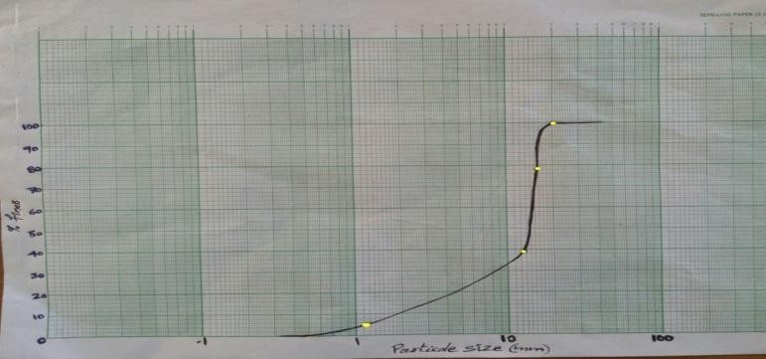

IS  Sieve No. | Particl e Size D  (mm) | Mass of CA  retaine d | % Mass retaine d | Cumulative  % retained | %  Finer
4.75 | 4.75 | 3 | 0.15 | 0.15 | 99.85
2.36 | 2.36 | 80 | 4 | 4.15 | 95.85
1.18 | 1.18 | 453 | 22.65 | 26.8 | 73.2
600 | .600 | 410 | 20.5 | 47.3 | 52.7
300 | .300 | 412 | 20.6 | 67.9 | 32.1
150 | 0.150 | 486 | 24.3 | 92.2 | 7.8
Pan |  | 156 | 7.8 | 100 | 0

Mass of dry sample was 2000g. The grading of the fine aggregates was within specified limits.
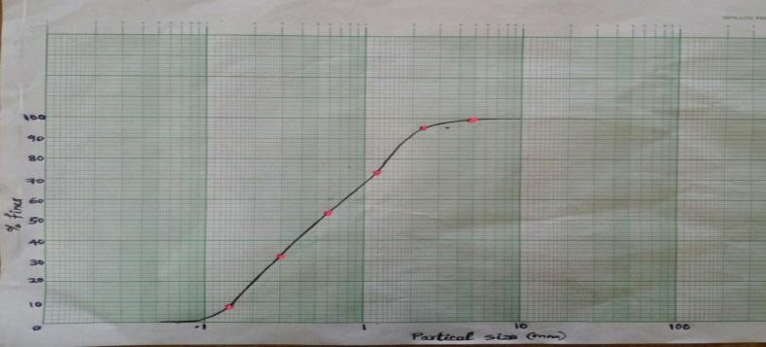
Results of tests on Aggregates
Test | Sample 1(%) | Sample 2(%) | Average(%)
ACV NA | 30.3 | 29.7 | 30

ACV-MA | 26.51 | 27.17 | 26.84
LA Abrasion  Test-NA | 52.91 | 52.67 | 52.8
LA Abrasion  Test-MA | 36.72 | 36.28 | 36.5
AIV Test  NA | 31.2 | 28.8 | 30
AIV Test  MA | 57.96 | 57.07 | 57.515

Type of aggregate | Specific gravity | Water  absorption (%)
Normal coarse aggregate | 2.67 | 0.5
Marble chips | 2.99 | _
Normal fine aggregate | 2.57 | 3
Marble dust | 2.3 | _

- COMPRESSIVE STRENGTH
In order to find the variations in the strength of concrete containing marble dust and marble chip as FA and CA, three control mix cubes are casted, which contains normal course aggregates and river sand as CA and FA. A number of concrete test specimens are also casted with varying FA and CA .The compressive strength of various concrete specimen with varying FA and CA content are given in the table.
The compressive strength of various concrete specimens with varying FA and CA are given in the table below

86
84
82
80
78
76 FA Replacement
74 CA Replacement
72
70
68
66
0% 5% 10% 15% 20% 50%
 | Type of mix With  Replaceme nt Level  % | Characteristi c compressive strength (N/mm2) | Age of curin g days | Average compressive strength  (N/mm2)
 |  |  |  | Specimen s with varying CA  contents | Specimen s with varying FA  contents
 | Normal mix (Control) | 20 | 28 | 26.58 | 26.58
 | Mix 1  5% | 20 | 28 | 26.54 | 26.59
 | Mix 2  10% | 20 | 28 | 23.07 | 26.64

Type of mix | Slump in mm  (FA replacement) | Slump in mm  (CAreplacement)
Normal mix(Control mix) | 79 | 79
Special mix 1  (5% replacement) | 78 | 79
Special mix 2  (10% replacement | 77 | 79
Special mix 3  (15% replacement | 77 | 81
Special mix 4  (20% replacement | 75 | 82
Special mix 5  (50% replacement | 72 | 84
IV.. RESULT AND DISCUSSION
Compressive strength
Fine aggregate replacement
The 150 mm size concrete cubes were used as test specimens to determine the compressive strength. The results of standard cubes are compiled in Table 16. The Indian standard method resulted in highly conservative results of compressive strength for the M20 grade concrete. Compressive strength was obtained as per IS: 516-1959.The 28 days compressive strength of green concrete is 12.9% higher than the control mix

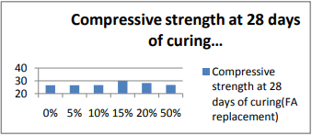
Variation in compressive strength at 28 days with FA replacement
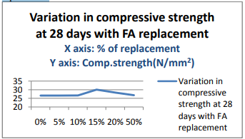

Above graphs shows the compressive strength of concrete containing marble dust. The strength increased with the increasing replacement of fine aggregate up to 15%. The specimen with 50% marble dust showed 12.9% more compressive strength than the reference mix at 28-days.
Coarse aggregate replacement The 150 mm size concrete cubes were used as test specimens to determine the compressive strength. The results of standard cubes are compiled in Tables-7. The Indian standard method resulted in highly conservative results of compressive strength for the M20 grade concrete. Compressive strength was obtained as per IS: 516-1959.The 28 days compressive strength of green concrete is 12.30% higher than the control mix.

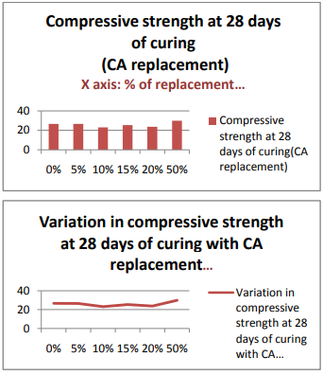
The above graphs shows the compressive strength of concrete containing marble chips. The strength increased with the increasing replacement of coarse aggregate up to 50%. The specimen with 50% marble chips showed 12.30% more compressive strength than the reference mix at 28- days.

V . CONCULUSION

All the experimental data shows that the addition of the marble wastes improves the physical and mechanical properties. These results are of great importance because this kind of innovative concrete requires large amounts of fine particles. Due to its high fineness of the marble dust it provided to be very effective in assuring very good cohesiveness of concrete. From the above study, it is concluded that the marble dust may be used as a replacement material for fine aggregate. Compressive strength of the concrete has increased• with increasing percentages of marble dust additions. The highest compressive strength has been demonstrated by MD-15 specimen. The chemical compositions of marble sludge• powder such as, MgO, Na 2 O K 2 O, MnO,

Fe2 O3 , Al2 O3 , CaO, and SiO 2 are comparable with that of cement. The replacement of coarse aggregate with 50%• marble chips (Green concrete) gives an excellent result in strength aspect and quality aspect. The results showed that the MC-50 mix induced higher compressive strength. Increase in the marble chip content improves the workability. This report clearly indicates an increasing trend and incentives for the greater use of manufactured and recycled marble aggregates in construction. There are, however limitations to the use such materials. Use of such concrete products in future will not only have an environmental impact but also facilitate economy.

REFERENCES

[1] Patel N.“Marble Waste: Opportunities For
Development of Low Cost Concrete” Global
research analysis ,Journal of construction and
building material ,Volume : 2 | Issue : 2 ,Feb 2013 ISSN No 2277 – 8160
[2] Shirule ,P.A “ partial replacement of cement with marble dust powder” International Journal of Advanced Engineering Research and Studies EISSN2249–8974
[3] Ali A. Aliabdo “Re-use of waste marble dust in the production of cement and concrete” construction and building material 50(2014)28-41 September 2013
[4] KursatEsatAlyamaç et al. “A preliminary concretemix design for SCC with marble powders”Construction and Building Materials 23 (2009) 1201–1210
[5] BouzianiTayeb“ Effect of Marble Powder
on the Properties of Self-Compacting Sand
Concrete” The Open Construction and Building
Technology Journal, 2011, 5, 25-29
[6] Shelke, V.M “Effect of marble powder with and without silica fume on mechanical properties of concrete” IOSR Journal of Mechanical and Civil
Engineering (IOSRJMCE)ISSN : 2278-1684

Volume 1, Issue 1 (May-June 2012), PP 40-45
[7] Noha M. Solimana “Effect of using Marble Powder in Concrete Mixes on the Behavior and Strength of R.C. Slabs” International Journal of Current Engineering and Technology ISSN 2277 – 4106 December 2013
[8] Hassan A. Mohamadien“ The Effect of marble powder and silica fume as partial replacement for cement on mortar” Interional journal of civil and structural engineering Volume 3, No 2, 2012
[9] Godwin A. Akeke, Maurice E. Ephraim et AL. “structural properties OF rice husk ash concrete.” International Journal of Engineering and Applied Sciences may 2013. Vol. 3, No. 3 , ISSN2305-8269
[10] Shazim Ali Memon et al “Production of Low Cost Self Compacting Concrete Using Rice Husk Ash” Advancing and Integrating Construction Education, Research & Practice August 4-5, 2008, Karachi, Pakistan First International Conference on
Construction In Developing Countries

