Design of Grid Integration Renewable Energy Resource for Power Quality Improvement of VSI for Induction Motor Drive
*V.SINDHU, **B.GOPAL
*PG Scholar, Dept of EEE, KITS Engineering College, Ponnekal; Khammam (Dt), Telangana, India.
**Assistant Professor, Dept of EEE, KITS Engineering College, Ponnekal; Khammam (Dt), Telangana, India.

ABSTRACT:
For the past few year renewable energy resources, without challenging environmental concerns has lead to significant increase in global power generation. The quality of power can be measured by using parameters such as voltage sag, harmonic and power factor. The inverter is controlled to perform as a multi-function device by incorporating active power filter functionality. A grid interfacing inverter to improve the quality of power at three phase distributed generating systems has been presented, the current harmonics and nonlinear load connected to the point of common coupling. Adaptable Voltage Source Inverter (AVSI), a single VSI is used in order to address both current as well as voltage PQ issues while injecting power from DERs to utility. The grid connected with renewable energy source has the capability of injecting active power to the grid, reduces source current distortion and reactive power compensation. The AVSI is termed adaptable for it can be operated in shunt or in series with respect to load, depending on the requirement. This paper proposes a Performance characteristics of three-phase asynchronous motor are analyzed with renewable energy sources is connected. Simulations have been carried out in Matlab–Simulink to study the performance of the proposed.

Keywords-Voltage control, Grid-connected inverter, microgrid, power quality, induction motor.

I. INTRODUCTION
The recent trends in small scale power generation using the with the increased concerns on environment and cost of energy, the power industry is experiencing fundamental changes with more renewable energy sources (RESs) or micro sources such as photovoltaic cells, small wind turbines, and micro grid being integrated into the power grid in the form of distributed generation (DG) [1-3]. The fuel cells are electrochemical devices that convert chemical energy directly into electrical energy by the reaction of hydrogen from fuel and oxygen from the air without regard to climate conditions, unlike hydro or wind turbines and photovoltaic array.
Fuel cells are different from batteries in that they require a constant source of fuel and oxygen to run, but they can produce electricity

continually for as long as these inputs are supplied. This can be accomplished mainly by resorting to wind and photovoltaic generation, which, however, introduces several problems in electric systems management due to the inherent nature of these kinds of RESs [4-5]. In fact, they are both characterized by poorly predictable energy production profiles, together with highly variable rates. As a consequence, the electric system cannot manage these intermittent power sources beyond certain limits, resulting in RES generation curtailments and, hence, in RES penetration levels lower than expected. However, the extensive use of power electronics based equipment and non-linear loads at PCC generate harmonic currents, which may deteriorate the quality of power controlled by HGS. Generally, current

controlled voltage source inverters are used to interface the intermittent RES in distributed system. Recently, a few control strategies for grid connected inverters incorporating PQ solution have been proposed. In [6-7] an inverter operates as active inductor at a certain frequency to absorb the harmonic current. But the exact calculation of network inductance in real-time is difficult and may deteriorate the control performance.
The integration of renewable energy into existing power system presents technical challenges and that requires consideration of voltage regulation, stability, power quality problems [8-9]. The power quality is an essential customer focused measure and it’s greatly affected by the operation of a distribution and transmission network. Nowadays, generation of electricity from renewable sources has improved very much. Since most renewable energy sources are intermittent in nature, it is a challenging task to integrate a significant portion of renewable energy resources into the power grid infrastructure.
Traditional electricity grid was designed to transmit and distribute electricity generated by large conventional power plants. The electricity flow mainly takes place in one direction from the centralized plants to consumers. In contrast to large power plants, renewable energy plants have less capacity, and are installed in a more distributed manner at different locations [10-11]. The integration of distributed renewable energy generators has great impacts on the operation of the grid and calls for new grid infrastructure. UPQC [12-13] was widely studied by many researchers as an eventual method to improve power quality in distribution system.
Only when PCC voltage goes beyond this tolerance band due to voltage interruptions, VSI goes to voltage injection mode. But, the

injected voltage in voltage injection mode of VSI appears across the feeder impedance. This means for a particular voltage injection, smaller the feeder impedance larger the current that needs to be supplied from inverter [14-15]. Therefore, the inverter current increases drastically in voltage injection mode when compared to inverter current during normal mode. This drastic increase in the inverter current calls for higher rating of the switches which makes the system cost inefficient.

II. A VSI CONFIGURATION IN DIFFERENT MODES
The topology of the proposed AVSI is shown in Fig.1.Split capacitor model of inverter is used and neutral point of inverter ($n^{'}$) is connected to S2 and S3 as shown. The two switches S2 and S3 are complimentary to each other and their states determine if the inverter is being operated in shunt or in series with respect to load. If S2 is open (S3 closed) then VSI appears in shunt with respect to load and $n^{'}$is connectedto ground through S3 as illustrated in Fig.3.2. In contrast, if S2is closed (S3 open) then VSI appears in series with respect to load and $n^{'}$is connected to terminal node as illustrates in Fig.3. The DC link voltage is maintained such that, VDC is 1.6times the peak phase voltage as suggested.
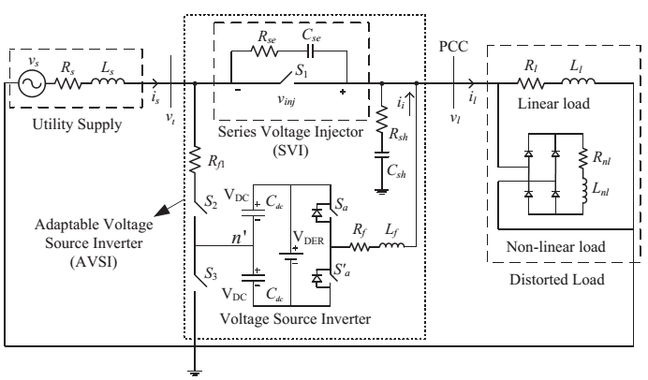
Fig.1. Proposed topology of single phase AVSI, supported by DERs at DC link

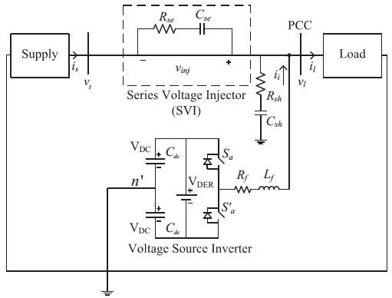
Fig.2. Current injection mode of AVSI
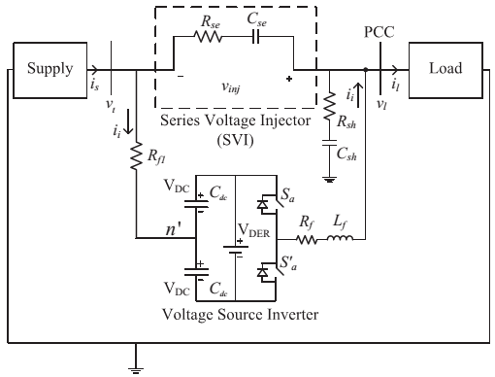
Fig.3. Voltage injection mode of AVSI
a) Shunt Current Injection mode (CIM)
Fig.2 shows the configuration in this mode. In this mode, switch S1 of SVI is closed and hence the source current bypasses the capacitor (Cse) and the resistor (Rse). Therefore, the injected voltage (vinj) by SVI is zero in this mode. And since the VSI is operated in shunt, it can inject current; in other words, it can deliver power from DERs and can also compensate for nonlinear load current. The inductor Lf and resistor Rf act as filters and are chosen by the procedure explained. The resistor Rsh and capacitor Csh help absorb the switch ripple of injected current.
b) Series Voltage Injection mode (VIM)
Fig.3 shows the configuration in this mode. In this mode, the switch S1 in SVI is open and inverter which appears in series (with respect to load) will maintain voltage across the capacitor (Cse) and the resistor (Rse). Rsh and

Csh are helpful in maintain the voltage at PCC in this mode. Lf and Cse are used as filters; the resistors Rf, Rf1 and Rse together act as a damping resistor. The filters are designed based on [10]. Rse should be sufficiently chosen depending on the voltage that could appear across Cse just before transferring from VIM to CIM or closing S1. That voltage divided by Rse should be well below the current rating of the switch S1 because, the capacitor Cse discharges through Rse and S1 when transfer redto CIM.
It can be clearly seen from Fig.3.2 and Fig.3.3 that current rating of S2 and S3 is same as current rating of inverter. Further, when S2 or S3 is open they block voltage appearing across terminal and ground. Therefore, voltage rating must be chosen accordingly. Whereas, for S1, source current and voltage that should be injected determine the current and voltage ratings respectively.

III. CONTROL SCHEME
a) Control during Current Injection Mode
The phase information of terminal voltage (vt) is obtained with the help of a phase locked loop (PLL). As S1 is closed in this mode, vt equals PCC voltage vl, neglecting the on state drop of switch S1. Next, magnitude of fundamental of load current (il) and fundamental phase with respect to vt are extracted by the help of the PLL output. Consider cenario-1, where a source current i∗ s is drawn in phase with vt, then active power drawn is product of RMS values of i∗ s and vt. Now cenario-2, in the absence of shunt VSI, active power is product of RMS of vt, RMS of fundamental of Il and cosine of angle between them. By equating the active powers in both the scenarios we get reference source current (i∗ s) as shown in(1), where Il1 is the RMS of fundamental of load current; φ1is the phase difference between fundamental

of il and vt; wt is PLL output or in other words, phase of vt.
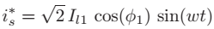 (1)
Equation (1) shows the reference source current in the case where load power equals supplied utility power. But, for power injection from DERs we need to change the magnitude of the input current (is) drawn. Therefore, from Il1 cos (φ1) if we subtract Pinj (power that should be injected) divided by Vt (RMS of vt) we get the required reference current as shown in (3.2). Also, the losses of switching and filter resistors are supplied by DERs; hence total power from DER is sum of Pinj and Ploss. Equation (3) represents the power balance. Once the reference is obtained, if is realized by using hysteresis control.
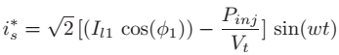 (2)
(3)
b) Control during Voltage Injection Mode
Minimum energy control proposed is employed in reference quantity generation. Equation (4) provides δ which should be phase difference between vl and vt such that minimum energy is used for voltage compensation. In (4), Vlb is base voltage of PCC; Vt is RMS of terminal voltage and φ1is phase difference between fundamental of load current and PCC voltage. Adding δ to PLL output (wt, phase of vt) gives phase of PCC voltage (vl). The reference PCC voltage (vl∗) is generated as shown in (5). Reference injection voltage, vinj∗ that should appear across SVI can be obtained by subtracting vt from vl∗. Finally, vinj∗ is realized using hysteresis control.
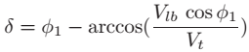 (4)

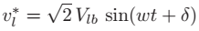 (5)
c) Mode Transfers; a Dual Band Strategy
Transfers between VIM and CIM are very crucial. The conditions that are to be met for mode transfer are discussed first. The RMS value of terminal voltage (vt) is always monitored. When the RMS value is beyond (1.0 ± a) pu band then AVSI goes from CIM to VIM. This is similar to the band concept proposed in [7] where in current is controlled if RMS is inside band and voltage is controlled when RMS goes outside band. But, in a real time scenario, if the RMS is at lower or upper limit and oscillating a little around that limit then unnecessary mode transfers would take place. The modes would keep changing even for little deviations from the hard set limit. To prevent this unnecessary mode transfers a dual band strategy is proposed. In this strategy, AVSI goes from CIM to VIM only if the RMS of vt is beyond (1.0 ± a)(first band). But to transfer back to CIM, the RMS should fall inside the band (1.0 ± b), a second band. If we make b < at hen we can prevent any unnecessary mode transfers because of small oscillatory variations at the limits. This is illustrated in Fig.4.
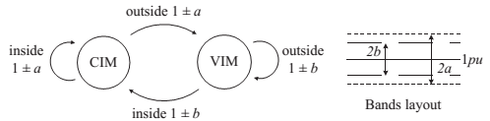
Fig.4. State diagram representation of Dual band strategy
After the conditions are met for mode transfer, strategies to make the transfer

seamless are discussed below. Absence of proper control during transfer could result in unwanted transients. Consider mode transfer from CIM to VIM, if we apply a sudden voltage across the capacitor it can draw huge current from the inverter, which may exceed the VSI current rating. So, the reference voltage $v_{inj}^{*}$as obtained from above process is not directly given as reference. It is multiplied by acubed ramp which starts raising at the event of mode transfer and later on saturates or clamps to 1.0.This ensures that voltage across capacitor slowly rises from zero to the desired value resulting in a smooth seamless mode transfer. In case of transfer from VIM to CIM, as explained before voltage across capacitor just before transfer should be as close to zero as possible if not S1 could be damaged if discharging current of Cse exceeds the current rating of the switch. To prevent this, the mode transfer form VIM to CIM happens after a little delay until $v_{inj}^{*}$ becomes sufficiently small.

IV. INDUCTION MOTOR
An asynchronous motor type of an induction motor is an AC electric motor in which the electric current in the rotor needed to produce torque is obtained by electromagnetic induction from the magnetic field of the stator winding. An induction motor can therefore be made without electrical connections to the rotor as are found in universal, DC and synchronous motors. An asynchronous motor’s rotor can be either wound type or squirrel-cage type.
Three-phase squirrel-cage asynchronous motors are widely used in industrial drives because they are rugged, reliable and economical. Single-phase induction motors are used extensively for smaller loads, such as household appliances like fans. Although traditionally used in fixed-speed service, induction motors are increasingly being used with variable-frequency drives (VFDs) in

variable-speed service. VFDs offer especially important energy savings opportunities for existing and prospective induction motors in variable-torque centrifugal fan, pump and compressor load applications. Squirrel cage induction motors are very widely used in both fixed-speed and variable-frequency drive (VFD) applications. Variable voltage and variable frequency drives are also used in variable-speed service.
In both induction and synchronous motors, the AC power supplied to the motor’s stator creates a magnetic field that rotates in time with the AC oscillations. Whereas a synchronous motor’s rotor turns at the same rate as the stator field, an induction motor’s rotor rotates at a slower speed than the stator field. The induction motor stator’s magnetic field is therefore changing or rotating relative to the rotor. This induces an opposing current in the induction motor’s rotor, in effect the motor’s secondary winding, when the latter is short-circuited or closed through external impedance. The rotating magnetic flux induces currents in the windings of the rotor; in a manner similar to currents induced in a transformer’s secondary winding(s). The currents in the rotor windings in turn create magnetic fields in the rotor that react against the stator field. Due to Lenz’s Law, the direction of the magnetic field created will be such as to oppose the change in current through the rotor windings. The cause of induced current in the rotor windings is the rotating stator magnetic field, so to oppose the change in rotor-winding currents the rotor will start to rotate in the direction of the rotating stator magnetic field. The rotor accelerates until the magnitude of induced rotor current and torque balances the applied load. Since rotation at synchronous speed would result in no induced rotor current, an induction motor always operates slower than synchronous speed. The difference, or “slip,” between actual

and synchronous speed varies from about 0.5 to 5.0% for standard Design B torque curve induction motors. The induction machine’s essential character is that it is created solely by induction instead of being separately excited as in synchronous or DC machines or being self-magnetized as in permanent magnet motors.
For rotor currents to be induced the speed of the physical rotor must be lower than that of the stator’s rotating magnetic field (n_{s}); otherwise the magnetic field would not be moving relative to the rotor conductors and no currents would be induced. As the speed of the rotor drops below synchronous speed, the rotation rate of the magnetic field in the rotor increases, inducing more current in the windings and creating more torque. The ratio between the rotation rate of the magnetic field induced in the rotor and the rotation rate of the stator’s rotating field is called slip. Under load, the speed drops and the slip increases enough to create sufficient torque to turn the load. For this reason, induction motors are sometimes referred to as asynchronous motors. An induction motor can be used as an induction generator, or it can be unrolled to form a linear induction motor which can directly generate linear motion.
Synchronous Speed:
The rotational speed of the rotating magnetic field is called as synchronous speed.
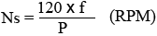 (6)
Where, f = frequency of the supply
P = number of poles
Slip:
Rotor tries to catch up the synchronous speed of the stator field, and hence it rotates. But in practice, rotor never succeeds in catching up. If rotor catches up the stator speed, there won’t be any relative speed between the stator flux and the rotor, hence no induced rotor current and no torque production to maintain

the rotation. However, this won’t stop the motor, the rotor will slow down due to lost of torque, and the torque will again be exerted due to relative speed. That is why the rotor rotates at speed which is always less the synchronous speed.
The difference between the synchronous speed (Ns) and actual speed (N) of the rotor is called as slip.
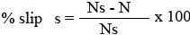 (7)

V. MATLAB/SIMULINK RESULTS
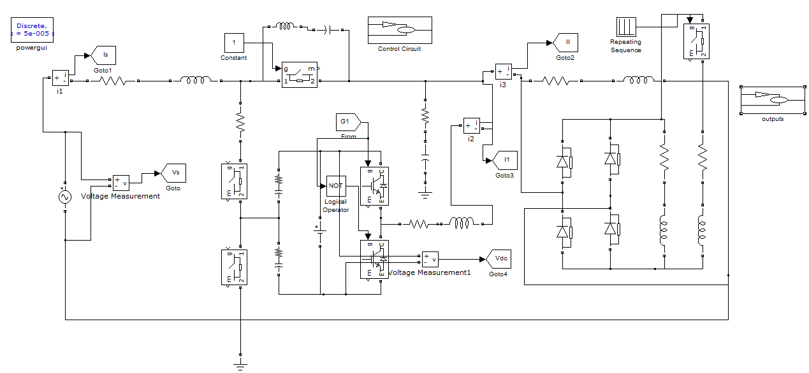
Fig.5 Matlab/Simulink model of Single phase AVSI, supported by DERs at DC link
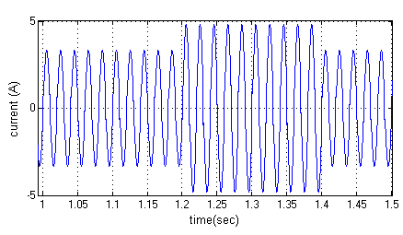
(a)

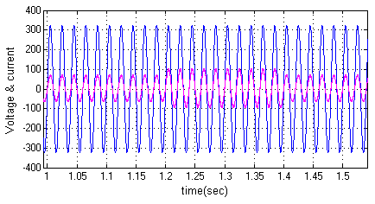
(b)
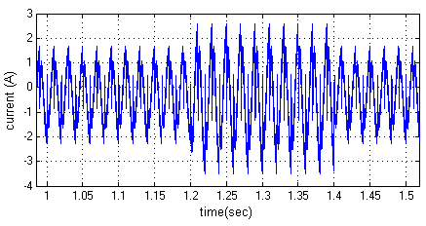
©
Fig.6 Dynamics during load change: (a) Load current (b) PCC voltage and Grid current and (c) Inverter current

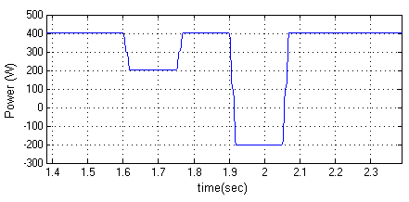
(a)
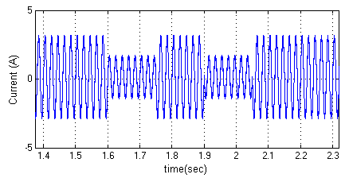
(b)

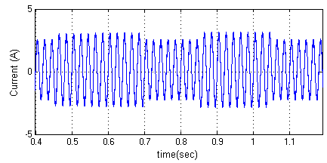
©
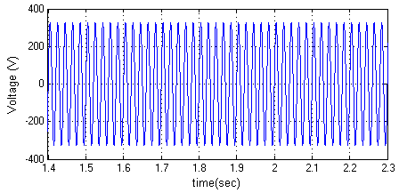
(d)
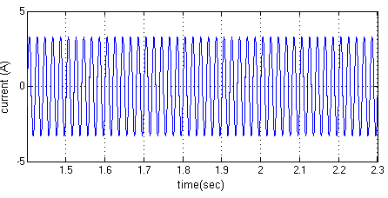
(e)
Fig.7. Dynamics during power injection variations: (a) Grid power, (b) Grid current, (c) Inverter current, (d) Load current and (e) PCC voltages
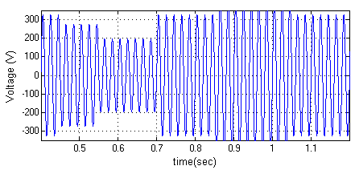
(a)

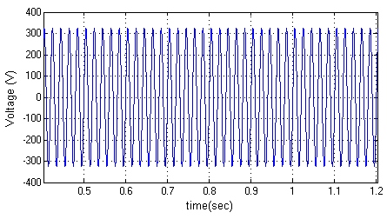
(b)
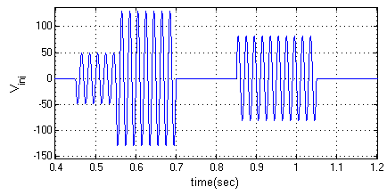
©
(d)

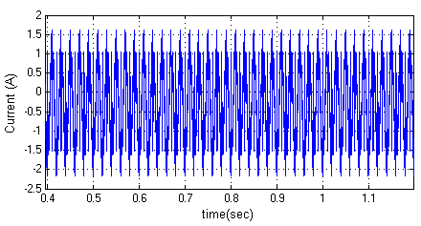
(e)

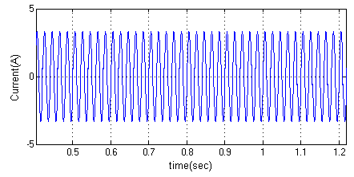
(f)
Fig.8. Dynamics during mode transfers: (a) Terminal voltage, (b) PCC voltage, (c) Injected voltage, (d) Grid current, (e) Inverter current and (f) Load current
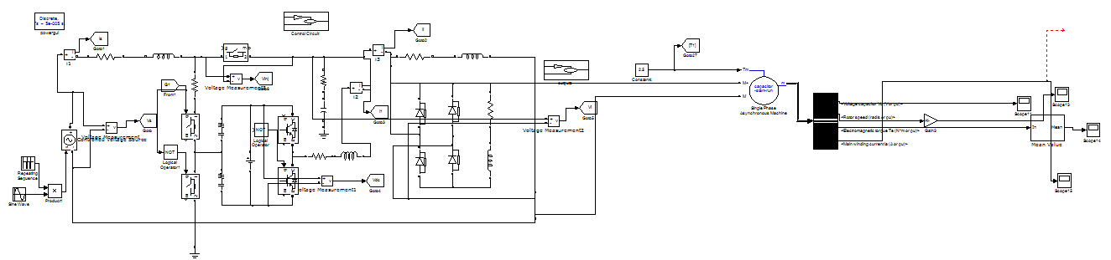
Fig.9 Matlab/Simulink model of Single phase AVSI, supported by DERs at DC link with Induction Motor connected
Case: 1 Machine output without controller
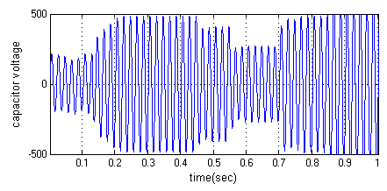
Fig.10 Capacitor Voltage (V)

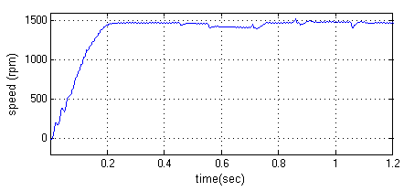
Fig.11 Speed of the Induction Motor
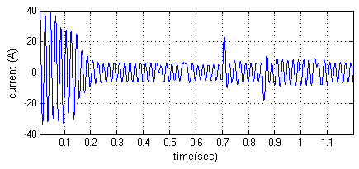
Fig.12 Stator Current (A)
Case: 2 Machine outputs with controller
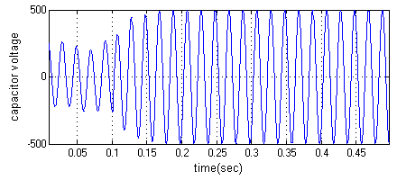
Fig.13 Capacitor Voltage (V)

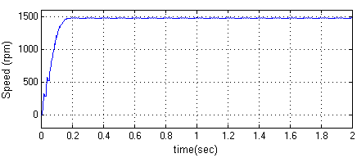
Fig.14 Speed of the Induction Motor

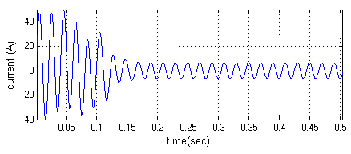
Fig.15 Stator Current (A)

VI. CONCLUSION
A new AVSI which has adaptable inverter capable of operating in shunt or series with respect to load is proposed. Integration of renewables to utility is achieved as the DC link of the VSI is supported by DERs. The functionalities of VSI being in shunt like power injection and current compensation are achieved. The simulation results are presented to validate these functionalities, grid interfacing inverter to eliminate the current harmonics, and to compensate the reactive power demand at common coupling point. Improved dynamic current harmonics and a reactive power compensation scheme for power distribution systems with generation from renewable sources has been proposed to improve the current quality of the distribution system. Advantages of the proposed scheme are related to its simplicity, modeling, and implementation. The induction motor is fed from the renewable energy. It had been observed that even at low operating condition this proposed system works efficiently with a very low torque ripple in induction motor.

REFERENCES
[1] J. Rocabert, A. Luna, F. Blaabjerg, and P. Rodriguez, “Control of power converters in AC microgrids,” IEEE Trans. Power Electron., vol. 27, no. 11, pp. 4734–4749, Nov. 2012.

[2] M. Aredes, J. Hafner, and K. Heumann, “Three-phase four-wire shunt active filter control strategies,” IEEE Trans. Power Electron., vol. 12, no. 2, pp. 311–318, Mar. 1997.
[3] S. Naidu and D. Fernandes, “Dynamic voltage restorer based on a fourleg voltage source converter,” Gener. Transm. Distrib., IET, vol. 3, no. 5, pp. 437–447, May 2009.
[4] N. Prabhakar and M. Mishra, “Dynamic hysteresis current control to minimize switching for three-phase four-leg VSI topology to compensate nonlinear load,” IEEE Trans. Power Electron., vol. 25, no. 8, pp. 1935– 1942, Aug. 2010.
[5] G.Satyanarayana., K.N.V Prasad, G.Ranjith Kumar, K. Lakshmi Ganesh, "Improvement of power quality by using hybrid fuzzy controlled based IPQC at various load conditions," Energy Efficient Technologies for Sustainability (ICEETS), 2013 International Conference on , vol., no., pp.1243,1250, 10-12 April 2013.
[6] F. Wang, J. Duarte, and M. Hendrix, “Grid-interfacing converter systems with enhanced voltage quality for microgrid application; concept and implementation,” IEEE Trans. Power Electron., vol. 26, no. 12, pp. 3501– 3513, Dec. 2011.
[7] X.Wei, “Study on digital pi control of current loop in active power filter,” in Proc. 2010 Int. Conf. Electr. Control Eng., Jun. 2010, pp. 4287–4290.
[8] M. Aiello, A. Catalioti, S. Favuzza, G. Graditi, - Theoretical and Experimental Comparison of Total Harmonic Distortion Factors for the evaluation of Harmonic and Inter harmonic Pollution of Grid Connected."IEEE Transactions on Power Delivery, Vol. 21, No. 3, July 2006.
[9] .I. M. A. Myrzik, and M. Calais, Member, IEEE -String and Module Integrated Inverters for Single-Phase Grid Connected Photovoltaic

Systems - A Reviewll. Power Technical Conference Proceedings, 2003 IEEE Bologna.
[10] P. Anjana and H. P. Tiwari, “Electrification by mini hybrid PV-solar/wind energy system for rural”, remote and Hilly/trible areas inRajasthan(India)Electric Utility ,The 4th International Conference on Deregulation and Restructuring and Power Technologies (DRPT), (2011).
[11] M. M. Mahmoud, “Experience results and techno-economic feasibility of using photovoltaic generators instead of diesel motors for water pumping from rural desert wells in Jordan”, IEE Proceedings on Generation, Transmission and Distribution, vol. 137, no. 6, (1990), pp. 391–394.
[12] A. K. Daud and M. M. Mahmoud, “Solar powered induction motor-driven water pump operating on a desert well, simulation and field tests”, Renewable Energy, vol. 30, no. 5, (2005), pp. 701–714.
[13] B. Singh*, C. L. Putta Swamy and B. P. Singh, “Analysis and development of a low-cost permanent magnet brushless DC motor drive for PV-array fed water pumping system”, Solar Energy Materials and Solar Cells, vol. 51, no. 1, (1998), pp. 55–67.
[14] M. K. Mishra and K. Karthikeyan, “Design and analysis of voltage source inverter for active compensators to compensate unbalanced and nonlinear loads,” in Proc. IEEE Int. Power Eng. Conf., 2007, pp. 649–654.
[15] A. Ghosh and A. Joshi, “A new approach to load balancing and power factor correction in power distribution system,” IEEE Trans. Power Del., vol. 15, no. 1, pp. 417–422, Jan. 2000.

