A Three Level LC-Switching Based Voltage Boost NPC Inverter
P.LEKUZ KUMAR
PG Scholar, Department of Electrical and Electronics Engineering, Narsimha Reddy Engineering College, Hyderabad-500100

ABSTRACT
Single stage high voltage gain boost inverter is getting popularity in applications like solar-PV, fuel cell, UPS systems etc. Recently, single stage voltage boostmultilevel Z-Source inverter (ZSI) and Quasi Z-source inverter (QZSI) have been proposed forDC-AC power conversion with improved power quality. Multilevel ZSI uses more number of high power passive components in the intermediate network which increase the system size and weight. Also its input current is discontinuous in nature which is not desirable in some of the applications like fuel cell, UPS systems, hybrid electric vehicle etc. In this paper a continuous current input three level LC- Switching based voltage boost neutral point clamped (NPC) inverter is proposed which uses comparatively less number of high power passive components at the same time retains all the advantages of multilevel QZSI/ZSI. It is able to boost the input DC voltage and give required three level AC output voltage in a single stage. Steady state analysis of the proposed inverter is discussed to formulate the relationship between the input DC voltage and three level AC output voltage. A unipolar PWM technique devised for the proposed inverter to eliminate first center band harmonics is also presented. The proposed converter has been verified by simulation in MATLAB Simulink as well as performing experiment with the help of a laboratoryprototype.

INTRODUCTION
N present days multilevel voltage source inverter(VSI)is usedinawiderangeofapplicationslikephotovoltaic(PV) system, uninterrupted power supply (UPS), fuelcell,wind power, hybrid electric vehicle (HEV) etc.[1]-[4].Multilevel VSI provides advantages like better powerquality,smaller output AC filter requirements, lower voltage stressacrossthe inverter switches. However, conventionalmultilevelVSI behaveslikebuckconverter[5]i.e.peakACoutputvoltageis less than the input DC link voltage. Inapplications likePV system, fuel cell, UPS etc. the required ACoutputvoltage level is achieved by using either a DC-DCconverterbefore the VSI or a transformer after the VSI [6]-[7].But,more number of power converter stages increases systemcontrol complexity and decreases the system efficiency[8].Similarly, inclusion of line frequency transformer increasesthesystem size and weight [9]. In multilevel VSI, shootthrough(i.e. switching all the switches in the

inverter leg)resultsdead short circuit of the source. Shoot-through isavoidedby providing dead band between switching control signalfed
to the complementary switches of inverter leg,whichintroduces distortion in the output AC voltage. ZSI addressestheabove issues and is able to boostthe input DC voltage to achievethe required AC voltage in a single stage[10]-[13].Conventional three level Z-Source Neutral point clamped(NPC)inverters are explored for medium power and lowpowerapplications [14]-[15]. It provides better power quality at thesametime voltage stress across switches and output filterrequirementare less. This uses two isolated DC sources whichmayrequire isolation transformer and additional rectifier circuits(incase isolated DC sources are not readily available). Itisprimarily operated in three states i.e. non-shoot throughstate, zerostate and shoot-through state. In multilevel ZSIshoot-throughstate is utilized along with passive reactive element toboost the input DC voltage. It is similar to the zero stateofmultilevel VSI where no power is transferred to the load.Innon-shoot through state power is transferred from DC source toACload, which is similar to the active state of themultilevelVSI. However, use of more number of high powerpassivereactive elements in the intermediate network as well asisolatedDCpower supply increases the system size, weight andcost.In literature [16]-[17] a single LC impedancenetwork based three level ZSI is discussed which uses less numberofhigh power passive components (two capacitors andtwoinductors) andsinglesplit-DCsource.
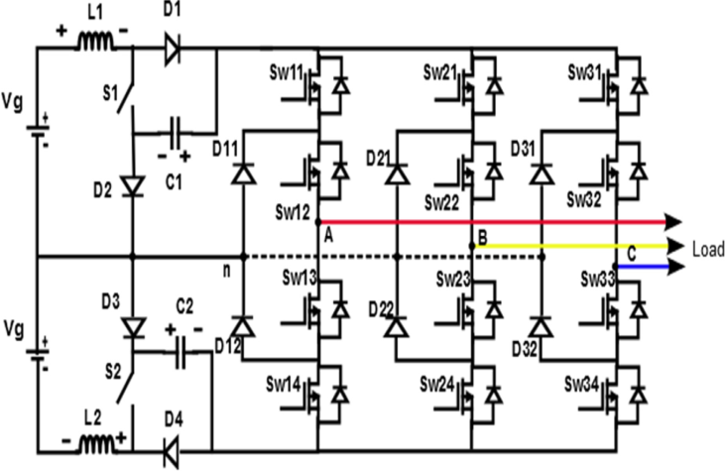

THREE LEVEL LC-SWITCHING BASED VOLTAGEBOOST NPC INVERTER
Theschematic diagram of three level LC- Switching based voltage boost NPC inverter, which is able to boost the input DC voltage source (‘Vg’) and give required three level AC voltage unlike conventional NPC VSI. Here the input source can be either two equal DC sources or single split DC source. This single split DC can be created byfeeding a DC source parallel to two series connected capacitors where, the interconnection point between these capacitors can be taken as neutral point [26]. The intermediate network between DC source and inverter leg is comprised of two inductors (L₁, L₂), two capacitors (C₁, C₂), two active switches (S₁, S₂) and four diodes (D₁, D₂, D₃and D₄). Whereas, conventional three level Z-Source NPC inverter uses four inductors, four capacitors and two diodes in the intermediate network between inverter leg and input DC as discussed in literature [14]-[15]. In these conventional Z- Source NPC inverter diodes are connected in series with the input DC source to boost the voltage and the input current is discontinuous in nature. In [24], the NPC Quasi Z-Source inverter is discussed where, the input current is continuous in nature but, it uses equal values of four inductors, four capacitors and two diodes in the intermediate network as discussed in the introduction. Whereas, the proposed inverter uses half the number of passive components (two inductors and two capacitors) in the intermediate network by utilizing extra two switches (S₁ and S₂) and two diodes at the same time maintains all the advantages of NPC Quasi Z-Source inverter. As a result, the proposed inverter can be useful in the applications where size and weight are main constraints. Traditional NPC three level VSI is basically operated in two states i.e. active state (or non-shoot through state) and zero state to give three distinct voltage levels (i.e. +V_{dc}, 0, -V_{dc}). Whereas, the proposed inverter uses additionalone more state

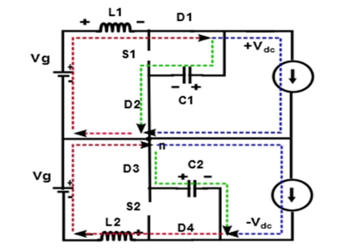

It is similar to the active state of conventional NPC VSI where power is transferred from DC source to AC load. In this interval of operation the AC load attains either ‘+Vdc’ or ‘– Vdc’ voltage level across AC load with respect to neutralpoint ‘n’. The switches S_{wx1}, S_{wx2} (where, x=1, 2, 3) are switched ‘ON’ and switch ‘S1’ is switched ‘OFF’ to achieve ‘+Vdc’ across AC load with respect to neutral point ‘n’, which in turn forward biases the diodes ‘D1’and‘D2’. As a result, both source ‘Vg’ and inductor ‘L1’ energize the capacitor ‘C1’ as well as supply power to the load as shown in Fig.2. Similarly, the switches S_{wx3}, S_{wx4} are switched ‘ON’and
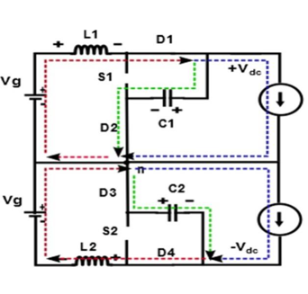
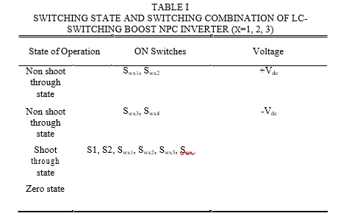
PWM CONTROL OF LC-SWITCHING BOOSTNPC INVERTER
The gate control signal for the inverter leg switches are generated using unipolar PWM technique in each phase for eliminating first center band harmonics as well as to achieve three level pole voltages [25]. Here, for each phase two modulating sine waves of 180 degrees phase displacement (V_{a}(t) and –V_{a}(t)) are compared with high frequency triangular carrier signal (V_{tri}(t)) as shown in Fig.6. For three phases these modulating signals (V_{a}(t) and –V_{a}(t)) are phase displaced by 120 degrees and compared with triangular carrier signal to generate gate control signal for the inverter leg switches. The shoot through gate signal is generated by comparing two fixed reference signals (V_{st} and -V_{st}) with the carrier signal (V_{tri}(t)). The voltage gain factor (G) decides the amplitude of fixed signals (V_{st} and -V_{st}) as well as modulating signals (V_{a}(t) and–V_{a}(t)). For ensuring shoot-through state not to impede active state (or non-shoot through state), shoot-through state is placed within the zero state in each switching cycle as shown in Fig.6. To ensure voltage balance across the capacitors a shoot through offset is added by using the control logic presented in [28]. The shoot through gate signal is fed to the switches in the intermediate network (‘S1’ and ‘S2’). Whereas, gate signal fed to the inverter leg switches are the combination of shoot through signal as well as signal generated from the comparison of modulating signals and carriersignal.

SIMULATION AND EXPERIMENTALRESULTS
The proposed inverter has been analyzed and verified by performing simulation in MATLAB Simulink as well as experiment. The experimental validation has been done by developing a laboratory prototype. The circuit parameters have been taken for simulation are shown in Table. II. The LC-Switching boost NPC multilevel inverter has been simulated to achieve phase voltage (Vph) of 110 Volts (r.m.s) from 48 volts input DC supply (V_{g}). Using (15) and (18), for the above desired phase voltage, shoot-through duty ratio (D) as well as modulation index (M) have been found to be 0.4091 and 0.5909 respectively. Carrier frequency (f_{s}) of 2.5 kHz has been used to generate PWM gate signal fed to the switches. Modulating signal frequency has been taken same as the frequency of required output AC voltage. Performing simulation, the voltage developed across both the capacitors ‘C1’, ‘C2’ have been found to be same as theoretical values (using (11)) i.e. V_{C1}=V_{C2} ≈ 260 volts with negligible ripple as shown in Fig.7 (c) and Fig.7 (d). Similarly, the input current (i_{L}) for the load 160Ω has been found to be same as estimated values (calculated using (14)) i.e. i_{L}≈6 Amperes as shown in

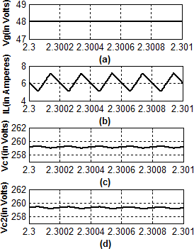
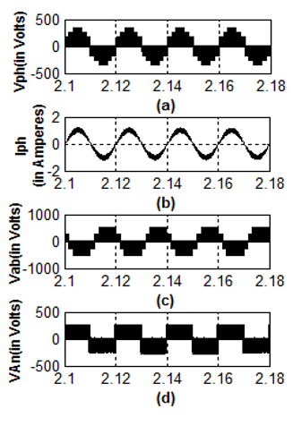

CONCLUSION
In this paper a three level LC-Switching voltage boost NPC inverter is presented. The proposed inverter is able to boost the input DC voltage and give required three level AC output in a single stage unlike conventional NPC VSI. It utilizes the shoot-through state for boosting up the voltage. In comparison to three level conventional NPC ZSI and NPC Quasi-ZSI, the LC-switching boost inverter uses single split DC source as well as less number of high power passive reactive elements which results weight and size reduction. In addition to these advantages the continuous input current of the proposed inverter makes it suitable for the applications like fuel cells, UPS system, PV system etc. The steady state operation of the inverter is discussed and voltage gain function is derived. PWM control strategy used for the switching as well as restriction on modulation index and shoot-through duty ratio is also presented. The simulation has been carried out using MATLAB Simulink along with experimental analysis has been done by developing laboratory prototype to verify proposedinverter.

