A NOVEL OF CUSTOMER REVIEW TOWARDS GREEN PRODUCTS
MOUNIKA.M
Associate professor & HOD, Arvindaksha school of management.(AESS). Specialisation​: MBA (Marketing and HRM).

ABSTRACT
Consumer’s awareness about green products is important in guiding the green consumer purchasing behavior. The study brings out green product awareness among the consumers in Kanyakumari District. The main objective of this study is to know the consumer awareness about green products. The data was collected from 123 respondents. Secondary data was collected from the available literature sources. The core idea of green marketing is to create awareness among people on the environmental issues and how consumers would be helping the environment if they switch over to green products. Thus green marketing aims to provide more information to people and also gives consumers more choices to switch over to green lifestyle.
Key words: green product, green attribute, environmental degradation, consumer awareness.

INTRODUCTION
As the world‟s economy is hurriedly developing, the global environment is increasingly weakening. Protecting environment and creating a safe living environment has become one of the most important concerns of consumers. Green marketing generally aims to encourage environmentally friendly products and a safe environment where people can stay. According to the American Marketing Association green marketing is the marketing of products that are presumed to be environmentally safe. At present green marketing is broadly becoming a phenomenon throughout the world as concerns towards environment have begun in the past few decades. Every year the populations of people who are rotating towards green brands or environmental friendly products are increasing thus magnifying the phenomenon. The need for sustainable business practices by corporations around the world is identified to be a result of overall increase in the consumer awareness of lack of environmental protection and social inequities. Thus, businesses in nearly every industry nowadays want to protect “green” features of their products and services in

every chance they get. The success of any green marketing strategy is heavily dependable on its target consumers.
The core idea of green marketing is to create awareness among people on the environmental issues and how consumers would be helping the environment if they switch over to green products. Thus green marketing aims to provide more information to people and also gives consumers more choices to switch over to green lifestyle. Driven by the green consumption, enterprises begin to take customer as the guide of the green marketing strategy. A green consumer can be identified to be one who avoids any product which may harm damage to any living organism, cause deterioration of the environment during process of manufacturing or during process of usage, consume a large amount of nonrenewable energy, involves unethical testing on animals or human subjects (Elkington, 1994).

REVIEW OF LIERATURE
The study by Hari Sundar G. Ram et al. (2011) identified that the decision-making styles as Perfection/high quality-conscious consumer, Brand Consciousness, Novelty, Shopping Consciousness, Price Consciousness, Impulsiveness, Choice and
Brand loyalty.
The study by Moloy Ghoshal (2011) examined that green marketing was still in infancy. In the perception of marketing scholars, green marketing refers to eco-level and market segmentation and the role of structural factors and economic incentives in influencing consumer behavior. The green marketers must understand to satisfy two objectives: improved environmental quality and customer satisfaction.Charles W Lamb et al (2004) explained that Green Marketing‖ has also become an important way for companies to build awareness and loyalty by promoting a popular issue. By positioning their brands as ecologically sound, marketers can convey concern for the environment and society as a whole.
According to Roger A Kerin et al (2007), Green Marketing takes many forms. It comes from product development opportunities that emanate both from consumer research and its Pollution Prevention Pays‖ program. This program solicits employee suggestions on how to reduce pollution and recycle materials.
The study by Meenakshi Handa(2006) has indicated that Activist groups and the media have played a major role in enhancing the environmental awareness and consciousness of consumers in recent years. Most studies on the subject show that although the awareness and environmental behavior of consumers across countries, educational levels, and age and income groups may differ, environmental concerns are increasing worldwide.

- OBJECTIVES
  - The impacts of respondents demographic
variables on their awareness towards green products
  - Consumer awareness towards consequence of environment degradation
  - To understand insight the ability to identify green attributes in green products
  - Impact of gender on the ways of identifying green products

RESEARCH METHEDOLOGY
A descriptive research was undertaken to meet the objectives of this study with the collection of both secondary and primary data. The primary data was collected from respondents in
Kanyakumari District through a questionnaire designed for a sample of 123 respondents, samples from Kanyakumari District representing, both genders, different age groups, education level, marital status, employment and monthly income. A structured questionnaire with a five point likert scale technique for measuring consumer awareness towards green marketing has been used. The data collected from the respondents are tabulated and analyzed into logical statements using percentage, chi-square and mean score analysis. Secondary data was collected from the available literature, journals and web search.

IMPACT OF DEMOGRAPHIC PROFILE ON GENDERWISE CONSUMER AWARENESS
The demographic variables taken into consideration for the analysis of gender wise consumer awareness are age, educational level, marital status, employment and monthly income. The following table 1.1 presences the analysis.

Table 1 Demographic profile of the respondents on their awareness towards green products

Sl. No. | Variables | Gender |  | Total | X2 | P Value
 |  | Male | Female
1. | Age  Up to 20 | 3  (5.26) | 2  (3.03) | 5  (4.06)
 | 21-30 | 17  (29.82) | 49  (74.24) | 66  (53.65)
 | 31-40 | 28  (49.12) | 8  (12.12) | 36  (29.26) | 27.381 | .000
 | 41-50 | 3  (5.26) | 2  (3.03) | 5  (4.06)
 | 51-60 | 2  (3.50) | 3  (4.54) | 5  (4.06)
 | Above 60 | 4  (7.01) | 2  (3.03) | 6  (4.87)
 | Total | 57 | 66 | 123
2. | Educational Qualification Up to High Secondary  Graduate Post graduate Professionals  Others | 1 | 4 | 5
 |  | (1.75) | (6.06) | (4.06)
 |  | 8 | 11 | 19
 |  | (14.03) | (16.66) | (15.44)
 |  | 37  (64.91) | 37  (56.06) | 74  (60.16) | 2.017 | .733
 |  | 10 | 13 | 23
 |  | (17.54) | (19.69) | (18.69)
 |  | 1 | 1 | 2
 |  | (1.75) | (1.51) | (1.62)
 | Total | 57 | 66 | 123
3. | Marital status | 46 | 11 | 72
 | Married | (80.70)  26 | (16.66)  40 | (58.53)  51 | 21.502 | .000
 | Unmarried | (45.61) | (60.60) | (41.46)
 | Total | 57 | 66 | 123
4. | Employment | 39 | 21 | 60
 | Private employees | (68.42) | (31.81) | (48.78)
 |  | 6 | 4 | 10
 | Govt. employees | (10.52) | (6.06) | (8.13)
 |  | 1 | 1 | 2 | 22.968 | .000
 | Business | (1.75) | (1.51) | (1.62)
 |  | 5 | 27 | 32
 | Service | (8.77) | (40.90) | (26.01)
 |  | 6 | 13 | 19

 | Others | (10.52) | (19.69) | (15.44)
 | Total | 57 | 66 | 123
5. | Monthly income
 | Up to 20,000 | 1 | 2 | 3
 |  | (1.75) | (3.03) | (2.43)
 | 21,000-30,000 | 40 | 24 | 64
 |  | (70.17) | (36.36) | (52.03)
 | 31,000-40,000 | 1 | 7 | 8 | 16.529 | .002
 |  | (1.75) | (10.60) | (6.50)
 | 41,000-50,000 | 9 | 13 | 22
 |  | (15.78) | (19.69) | (17.88)
 | Above 50,000 | 6 | 20 | 26
 |  | (10.52) | (30.30) | (21.13)
 | Total | 57 | 66 | 123
Source: Primary Data

The above table reveals that except for educational qualification all the other demographic variable namely, age, marital status, employment and monthly income have significant impact on the gender wise awareness level of respondents about the usage of green products. Another important fact proved in this study is that 60 percent of the post graduate respondents are aware of the usage of green products. Regarding the married respondents 59 percentage are familiar with the need to use green products.
Another interesting fact is 49 percent of the respondents working in private organisations are aware of the need to use green products. Majority of the respondents that is 64 percent, in the group of income 21,000-30,000, have awareness towards the usage of green products. It is hearting to note the fact that the young generations in the group of 21-30 are aware (54 percent) are aware of need to use green products.

AWARENESS TOWARDS CONSEQUENCE OF ENVIRONMENT DEGRADATION

The environment degradation leads to many problems that would affect the lifestyle of the people. This study analyzes the awareness level of the respondents on the consequence of environment degradation and the results are given below table 2.

Table 2 Consequences of Environment Degradation
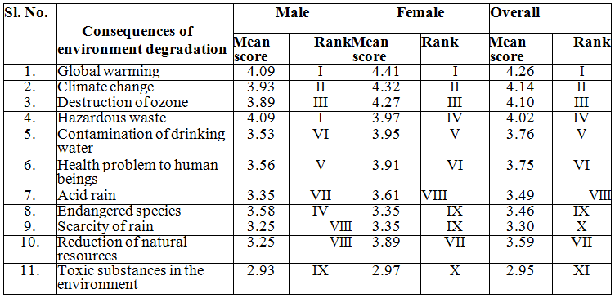

Source: Primary Data

The table 2 reveals that both the male and female respondents states that the three main consequence of environment degradation are global warming, climate change and destruction to ozone layer.

IDENTIFICATION OF GREEN PRODUCT ATTRIBUTES
If one needs to use green products, he should be aware the ways to identify green attributes that decides whether a products is green or not. The consumer should be aware of the features of the green products. The analysis in this regards is made and the result is given below the table no. 3

Table 3 Attributes of green products

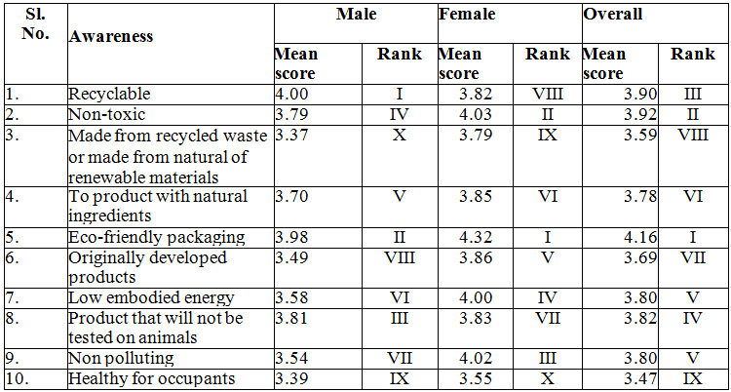
Source: Primary Data
The above table reveals that the main three green attributes known to the male respondents are recyclable nature of the product; eco-friendly packaging and the products will not be tested on animals. The female respondents say that the three main green attributes they can identify are eco-friendly packaging, non-toxic products and pollution free products. The overall results show that the three green attributes that can easily be identified are eco-friendly packaging, non-toxic products and the recyclable nature of the products.

THE WAYS OF IDENTIFYING GREEN PRODUCTS

Now a day the green products use different green symbols and labels to help the consumers to identify the green products.

This study analyze whether the respondents are able to identify the symbols, labels, logos and green brands and the result is given below.

Table 4 Ways of identifying green products

Method of identification | Gender |  | Total | X2 | P. Value
 | Male | Female
Label with the word organic Yes  No | 39  (68.42)  18  (31.57) | 54  (81.81)  12  (18.18) | 93  (75.60)  30  (24.39) | 2.977 | .065
Total | 57 | 66 | 123
Packaged in recycled of bio- degradable materials  Yes  No | 36  (63.15)  21  (36.84) | 23  (34.84)  43  (65.15) | 59  (47.96)  64  (52.03) | 9.821 | .002
Total | 57 | 66 | 123
Energy star label  Yes  No | 21  (36.84)  36  (63.15) | 44  (66.66)  22  (33.33) | 65  (52.84)  58  (47.15) | 10.918 | .001
Total | 57 | 66 | 123
Green seal / Green logo  Yes  No | 12  (21.05)  45  (78.94) | 19  (28.78)  47  (71.21) | 31  (25.20)  92  (74.79) | .971 | .219
Total | 57 | 66 | 123
Experience of using the brands  Yes No | 50  (87.71)  7  (12.28) | 48  (72.72)  18  (27.27) | 98  (79.67)  25  (20.32) | 4.245 | .032
Total | 57 | 66 | 123
Self-perception of knowledge  Yes No | 15  (26.31)  42  (73.68) | 19  (28.78)  47  (71.21) | 34  (27.64)  89  (72.35) | .093 | .460
Total | 57 | 66 | 123
Help from green product uses  Yes No | 47  (82.45)  10  (17.54) | 50  (75.75)  16  (24.24) | 97  (78.86)  26  (21.13) | .823 | .247
Total | 57 | 66 | 123
Source: Primary Data

The above table shows that the study analysis the significant relationship between the ways to identify green products and the gender. It is proved that there is significant relationship between all the above said methods of identifying green products and the gender. It also reveals that majority of the respondents an identify label (76 percent), uses experience

(80 percent), help from green product uses (79 percent) and energy star label (53 percent). But they lack self-perception knowledge and find difficult of identify green logo and seal.

SUGGESTIONS
  - This survey suggest that the better-educated consumers understand the environmental issues, are involved more fully and, hence, are more concerned about environmental quality and more motivated to participate in environmentally responsible behaviours.
  - One„s income level has a positive relation with environment sensitivity. Individual with high income will rise to support environmental sustainability and buy eco-friendly products. Income as predictor of environmental awareness and relates with positively with ecological knowledge and premium price of eco-friendly products.
  - Since there is lack of awareness regarding availability of eco-friendly products, companies should focus on advertising eco-friendly branding, in-store displays and pamphlets. Promotional campaigns may be used to further promote the use of eco-friendly products.
  - Therefore, marketers should target middle age and senior citizens for purchase of eco-friendly products through their integrated marketing communication activities.

CONCLUSIONS
Environment can damage the way of life of human being. They have the responsibility to protect nature and environment. Usage of green product will help them to change their life style into a green one. But the awareness level on the usage of green products among the people is very limited. There is a need to educate the people on the usage of green products and on identifying the green attributes of products they use. This would help to protect the environment for the future generation.

REFERENCES
- Charles W Lamb, Joseph H Hair and Carl McDaniel, Marketing, 7th Edition, Thomson Asia(P) Ltd, 2004, Singapore, pp. 517 - 518.
- Ghoshal, Moloy (2011), “Green Marketing – A changing concept in changing time”, BVIMR, Management Edge, Vol. 4, No. 1, pp. 82 – 92.
- Meenakshi Handa, Green Marketing: Drivers and Challenges, B-Cognizance IIITA e- Magazine, Oct-Dec, 2006, Vol. 2, Issue 11.
- www.google.com
- P Asha and Dr. R. Rathiha. Consumer Attitude Towards Green Products. International Journal of Advanced Research in Management, 8 (3), 2017 , pp. 01–07.
- P. Asha and Dr. R. Rathiha, Post Purchase Attitude of Green Consumers Using Green Products. International Journal of Marketing

and Human Resource Management, 8(3), 2017, pp. 9–15.
- Dr. Ramesh Chandra Rath, Puspita Acharya, AnoopaLaly and Bishnu Chanran Rout, Role of Nano Technology on Agri-Green Product Production Process: Emerging Needs and Challanges. International Journal of

- Advanced Research in Engineering and Technology, 8(1), 2017, pp 34 –50
Dr. N. Mahesh, Dr. R. Ganapathi, A Study On Determinants Of Consumers‟ Purchase Behaviour Towards Green Products. International Journal of Management, 3 (3), 2012, pp. 32–41

