### DESIGN OF AC GRID CONNECTED MULTILEVEL INVERTER TOPOLOGY FOR RENEWABLE ENERGY APPLICATIONS

**G.SHYAM**

Assistant professor, Dept of EEE, Nova College of Engineering and Technology, Jafferguda, Hyathnagar, Ranga Reddy

**ABSTRACT:** A novel topology for fell multilevel inverters which is reasonable for sustainable power source interfacing to lattice is proposed in this paper. The proposed topology altogether diminishes the utilization of number of dc voltage sources, switches, and control diodes as the quantity of yield voltage levels increment. The world electrical vitality utilization is rising and there is a relentless increment of the request on the power limit, effective creation, dispersion and use of electrical vitality. The conventional power frameworks are changing, number of sustainable power sources, for example, wind turbines, photovoltaic generators, energy units, little hydro, wave generators, are being coordinated into control frameworks at dissemination level. The multilevel converters has a fundamental impact in the combination of the sustainable power sources. This paper audits the use of multilevel converters in the mix of sustainable power sources. This new kind of converters are reasonable for high voltage and high power application because of their capacity to orchestrate waveforms with diminished symphonious bending. Number of topologies have been presented and broadly contemplated ,among the CHB topology is the best possible alternative from the perspective of measured quality and straightforwardness of control. Principle inconvenience of multilevel setup is increment in number of energy semiconductor switches and its unpredictability to configuration entryway driver circuit independently, its cost and exchanging misfortunes. Unpredictability of the framework decreases unwavering quality of the inverter. By diminishing number of switches for similar levels of voltages these drawbacks can be lessened viably This undertaking presents another method for getting a combined multilevel yield and furthermore utilizes PWM control systems for CHB topology, in this strategy, the quantity of dc voltage sources, switches, and control diodes utilized for the dc to air conditioning transformation is decreased. So this dc to air conditioning change fundamentally lessens the underlying expense. The methods of task are sketched out for 7-level inverter, as comparable modes will be acknowledged for larger amounts. Reproductions of seven level of the proposed inverter topology alongside with trial comes about are introduced. MATLAB simulink condition is utilized to recreate the outcomes.

**Key words**-Cascaded multilevel inverters,RES interfacing, symphonious contortion, lessened number of gadgets

**I. INTRODUCTION**

Multilevel voltage source inverter is perceived as a critical other option to the typical two level voltage source inverter particularly in high voltage application[1]. Utilizing multilevel system, the abundancy of the voltage is expanded, worry in the exchanging gadgets is lessened and the general music profile is made strides. Among the natural topologies, the most well known one is fell multilevel inverter. It displays a few alluring highlights, for example, straightforward circuit format, less segment include, secluded structure and dodge unbalance capacitor voltage issue. However as the quantity of yield level expands, the circuit ends up plainly massive because of the expansion in the quantity of energy gadgets. In this undertaking, it is proposed to utilize another procedure to acquire a multilevel yield utilizing less number of energy semiconductor changes when contrasted with customary fell multilevel inverter, which is appropriate for sustainable power source interfacing. Voltage source converters are additionally required for different mechanical applications, brilliant lattice innovations and so forth. Because of high power prerequisite in these applications, utilizing one power semiconductor switch specifically isn't fitting. For high power and medium voltage applications multilevel converters are presented [2]. Utilizing multilevel converters sustainable power sources can be effortlessly interfaced to the network. Utilizing a few low voltage DC sources, for example, capacitors, batteries and inexhaustible sources with arrangement control semiconductor switches high power converter can be accomplished. The appraised voltage of the switches depends just upon the rating of DC voltage sources to which they are associated. These converters have a few points of interest more than two level converters. Multilevel converters can create the yield voltages with low contortion and less dv/dt stresses. Little basic mode voltage decreases the worry in the direction of engine associated with multilevel converter. Information current with low twists, scope of the exchanging recurrence are further preferences of multilevel converters. In any case, because of expansive number of switches, each switch requires its related door drive circuit increment cost and intricacy. Major multilevel converter structures are Cascaded H connect converter, Diode clasped converter, Capacitor braced converter. Diverse heartbeat width balance methods grew, for example, sinusoidal heartbeat width regulation (SPWM), Selective symphonious disposal (SHE-PWM), space vector tweak (SVM) thus on[3]. In fell H connect converter, contingent upon the quantity of voltage levels required, some single stage full extensions or H spans are associated in arrangement with singular separate DC source. Number of voltage levels is equivalent to 2n+1 where n is the quantity of independent DC sources. In Diode clipped converter the greater part of the three stages share a basic DC transport, which limit the capacitance necessities of the converter. Consequently a consecutive topology is conceivable. Proficiency is high for principal recurrence exchanging. Be that as it may number of clipping diodes required is quadratic partner identified with number of levels, which can be unwieldy for units with a high number of levels. Capacitor clipped or flying capacitor structure is like diode clasped converter aside from that as opposed to utilizing clipped diodes, the inverter utilizes capacitors in their places. In this converter genuine and receptive power can be controlled. The huge number of capacitors empowers the inverter to ride through brief length blackouts and profound voltage droops. For genuine power transmission effectiveness is poor in this converter. Control is confounded to track all the voltage levels of capacitors. Since of its quick reaction and self-governing control, the utilization of a multilevel converter to control the recurrence and voltage yield from sustainable power sources will give huge favorable circumstances. These converters can likewise control the genuine and receptive power spill out of an utility associated sustainable power source source. Multilevel converters can control framework dynamic conduct, additionally decrease control quality issues, for example, voltage sounds and voltage awkward nature. In the event of PV framework it's favorable to utilize fell H connect converter as each converter requires isolate DC sources. Extra favorable circumstances are conceivable end of the DC/DC converters, huge lessening of the power drops caused by sun obscuring and consequently potential increment of proficiency and dependability. In the event of wind age, changing over factor extent, variable recurrence voltages created from twist generator into settled size, settled recurrence voltages is more favorable with multilevel converter to enhance effectiveness over an extensive variety of working focuses and vitality catch. Primary disservice of multilevel setup is increment in number of energy semiconductor switches and its intricacy to configuration entryway driver circuit exclusively, its cost and exchanging misfortunes. Multifaceted nature of the framework lessens unwavering quality of the inverter. By diminishing number of switches for similar levels of voltages these burdens can be lessened successfully. A solitary stage structure of a m-level fell inverter is represented in Figure 1. Each different dc source (SDCS) is associated with a solitary stage full-extension, or Hbridge, inverter. Every inverter level can create three extraordinary voltage yields, +Vdc, 0, and – Vdc by interfacing the dc source to the air conditioner yield by various mixes of the four switches, S1, S2, S3, and S4. To get +Vdc, switches S1 and S4 are turned on, though – Vdc can be acquired by turning on switches S2 and S3. By turning on S1 and S2 or S3 and S4, the yield voltage is 0. The air conditioning yields of each of the distinctive full-connect inverter levels are associated in arrangement with the end goal that the combined voltage waveform is the total of the inverter yields. The quantity of yield stage voltage levels m in a course inverter is characterized by m = 2s+1, where s is the quantity of discrete dc sources.

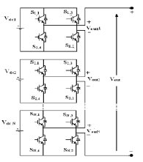

Fig1 Single-phase structure of a multilevel cascaded H-bridges inverter

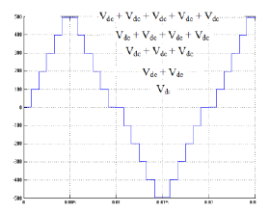

Fig 2 Output phase voltage waveform of an 11-level cascade inverter with 5 separate dc sources

Cascaded inverters are ideal for connecting renewable energy sources with an ac grid, because of the need for separate dc sources, which is the case in applications such as photovoltaic’s or fuel cells. Cascaded inverters have also been proposed for use as the main traction drive in electric vehicles, where several batteries or ultra capacitors are well suited to serve as SDCSs [4]. The cascaded inverter could also serve as a rectifier/charger for the batteries of an electric vehicle while the vehicle was connected to an ac supply as shown in Figure. Additionally, the cascade inverter can act as a rectifier in a vehicle that uses regenerative braking. The main advantages and disadvantages of multilevel cascaded H-bridge converters are as follows The number of possible output voltage levels is more than twice the number of dc sources (m = 2s + 1). The series of H-bridges makes for modularized layout and packaging. This will enable the manufacturing process to be done more quickly and cheaply.

**II. NUMBER OF LEVELS AND VOLTAGE RATING OF ACTIVE DEVICES**

A multilevel inverter, determining the number of levels will be one of the most important factors because this affects many of the other sizing factors and control techniques [5]. This margin can be incorporated into a design factor for the inverter. Because the dc link voltage and the voltage at the connection point can both vary, the design factor used in the rating selection process incorporates these elements as well as the small voltage drops that occur in the inverters during active device conduction. The product of the number of the active devices in series (m-1) and the voltage rating of the devices Vdev must then be such that



The minimum number of levels and the voltage rating of the active devices (IGBTs, GTOs, power MOSFETs, etc.) are inversely related to each other. More levels in the inverter will lower the required voltage device rating of individual devices; or looking

at it another way, a higher voltage rating of the devices will enable a fewer minimum number of levels to be used. Increasing the number of levels does not affect the total voltage blocking capability of the active devices in each phase leg because lower device ratings can be used.

**III. PROPOSED MULTILEVEL CONVERTER TOPOLOGY**

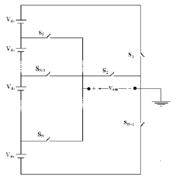

Fig 3: schematic of a Proposed multilevel converter topology

The number of required switches against required voltage levels is a very important element in the design. To provide a large number of output levels without increasing the number of bridges, a new power circuit topology and a suitable method to determine the dc voltage sources level for symmetrical and asymmetrical multilevel converter are proposed. The proposed circuit also provides decreased voltage stress on the switch by the series configuration of the applied bidirectional switches. The proposed converter consists of less number of switches when compared to the other familiar topologies. The initial cost reduces because of the switch reduction. So, it looks attractive and an apt one for industrial applications. The block diagram of the proposed multilevel inverter is shown in the the general circuit diagram of the proposed multilevel inverter is shown in the figure 2. The switches are arranged in the manner as shown in the figure. For the proposed topology, we just need to add only one switch for every increase in levels. So initial cost get reduced. Let us see operation in the next subdivision in detail for the seven-level inverter. The proposed multilevel inverter for seven levels is shown figure 3.The inverter consists of seven MOSFET switches and three separate DC sources with a load. By switching the MOSFETS at the appropriate firing angles, we can obtain the seven level output voltage. MOSFET is preferred because of its fast switching nature. The advantage of the new topology the reduction in the number of switches and hence the initial cost, Controlling becomes easier. Losses become less due to the elimination of the harmonics. Overall weight reduces because of the usage of less number of components

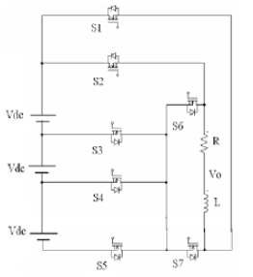

Figure 4. Circuit Diagram of a basic Seven Level Proposed Multilevel Inverter

**IV. SIMULATION RESULTS**

Simulation results of the proposed converter for seven levels using MATLAB/simulink. The PWM technique is used for pulse generation. The MOSFET switches are used because of its fast switching capability. The input supply for each DC source is 100V. The load used is a R-L load. The output waveform is phase voltage and it comprises seven levels. The PWM technique is used to produce the control signal . The MATLAB simulation circuit for the proposed inverter which comprises only seven MOSFET switches for producing seven levels is shown in the figure 4. The MATLAB circuit used for generating gate pulse using PWM technique is shown in the figure 6. The pulse generated by the circuit shown in the figure 10. The output waveform of the proposed inverter for seven levels with PWM technique is shown in the figure 9. The pulse is generated using comparison between constant DC voltage and power supply .The comparison is done using operational amplifiers. For the first pulse we give a DC voltage of lesser amplitude and moderate amplitude for the second pulse. Likewise we have to increase the amplitude to reduce the pulse width. The PWM technique is used to obtain a good harmonic spectrum. The gating pulse is generated from the above mentioned process and given separately to the respective MOSFETs. The supply is given through three separate DC sources. The R-L load is used for the simulation purpose. The simulation results show that the circuit is operating properly. The output waveform has three levels in the positive side and three levels in the negative side and a zero level. Totally there are seven levels. Thus the proposed multilevel inverter for seven levels is successfully simulated. And the results are shown below in sequential manner.

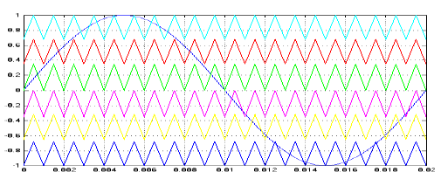

Fig 5: Triangular wave comparison with sine wave for the 7- level converter

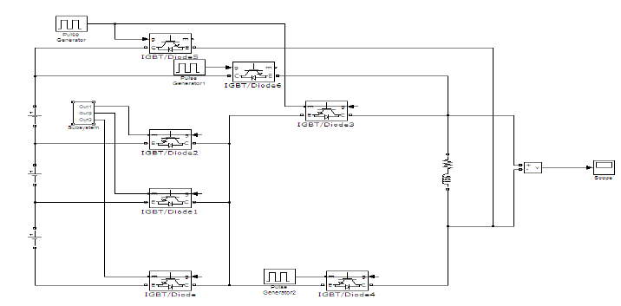

Fig 6: Proposed Multilevel Inverter for Seven Levels

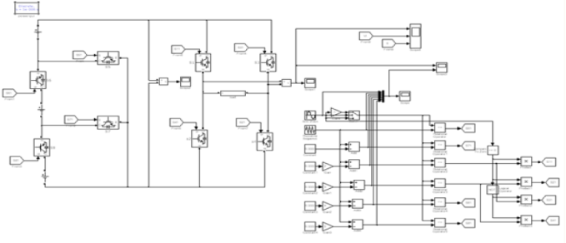

Fig 7 Simulink model of a praposed multilevel Converter

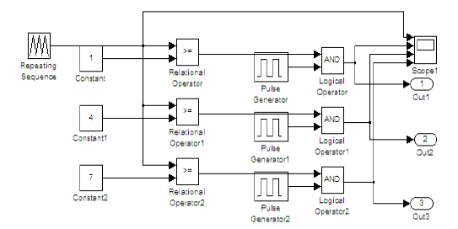

Fig 8: Gate Pulse Generation Circuit With PWM Technique

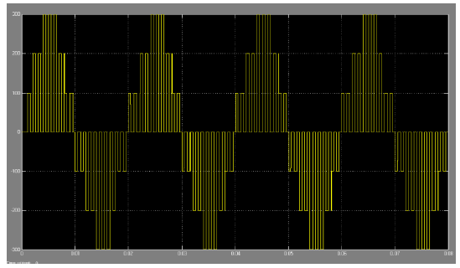

Fig 9 :Output Voltage Waveform Using PWM Technique



Fig 10 : Pulses Generated Using PWM Technique



Fig 11: Input voltage, load voltage and load current



Fig 12: Input Voltage THD Response 18.16%

**V. CONCLUSION**

A novel multilevel converter topology improvement is introduced in this paper. The recreation of the seven-level multilevel inverter is effectively done utilizing beat width regulation system for the proposed multilevel converter. The proposed topology altogether decreases the use of number of dc voltage sources, switches, IGBTs, and power diodes as the quantity of yield voltage levels increment. When we increment the levels, the quantity of switches utilized is less contrasted with the other topology. The most imperative and helpful component of the framework proposed is that it is advantageous for growing and expanding the quantity of yield levels, just without utilizing any bidirectional switches. The proposed strategy brings about the decrease of the quantity of switches, misfortunes and cost of the converter. In view of the exhibited exchanging calculation, the multilevel converter produces close sinusoidal yield voltage and subsequently, has low symphonious substance.. The proposed topology gives greater adaptability to originators and can produce more voltage levels without losing any level and shows bring down THD qualities.. Reenactment comes about demonstrates that the proposed converter topology produces an amazing yield voltage waveform with bring down request THD of yield voltage and current and subsequently which is appropriate for sustainable power sources interfacing to air conditioning framework.

**REFERENCES**

[1] Rodríguez, J. S. Lai, and F. Z. Peng, “Multilevel inverters: A survey of topologies, controls, and applications,” IEEE Transaction on Industrial electronics, vol. 49, no. 4, pp. 724–738, Aug. 2002

[2] Ebrahim Babaei, 2008, “A Cascade Multilevel Converter Topology With Reduced Number of Switches” IEEE Transactions on power electronics,Vol. 23, No.6.

[3] Peng Fang-Zen, Qian Zhao-ming, “Applications of cascade multilevel inverters”, Journal 0f Zhejiang Univ ersity SCIENCE vol.4, no.6, pp. 658-665, Nov.-Dec., 2003

[4] K. Corzine and Y. Familiant, “A New Cascaded Multilevel H-Bridge Drive”, IEEE Transactions Power Electron., Vol. 17, No.1, 2002, pp. 125

[5] H.S. Patel and R.G. Hoft, “Generalized Techniques of Harmonic Elimination and Voltage Control in Thyristor Inverters: Part I – Harmonic Elimination”, IEEE Trans.Ind.Appl., 3, 1973, pp. 310-317.

[6] Beser, E.; Camur, S.; Arifoglu, B.; Beser, E.K. , “ Design and application of a novel structure and topology for multilevel inverter,” in Proc. IEEE SPEEDAM, Tenerife, Spain, 2008, pp. 969 – 974

[7] L.M. Tolbert, F. Z. Peng, T. G. Habetler, “Multilevel PWM Methods at Low Modulation Indices,” IEEE Trans. Power Electron.,vol. 15, no. 4,

[8] E. Babaei, M. T. Haque, and S. H. Hosseini, “A novel structure for multilevel converters,” in Proc. ICEMS, 2005, vol. 2, pp. 1278–1283.

[9] Najafi, E.; Yatim, A.; Samosir, A.S.; “A new topology -Reversing Voltage (RV) - for multi level inverters, “ in Proc. IEEE 2nd International, PECon 2008, pp. 604 – 608.

[10] Babaei E. “A cascade multilevel converter topology with reduced number of switches,” IEEE Trans. Power Electron.,vol.23,no.6,pp 2657-2664,Nov.2008 .

[11] Zhong Du; Tolbert, L.M.; Chiasson, J.N.; Ozpineci, B.;, “A cascade multilevel inverter using a single DC source,” ,” in Proc. IEEE APEC’06, 2006, pp. 426 – 430.

[12] Babaei E, Hosseini S.H., “New cascaded multilevel inverter topology with minimum number of switches,” Elsevier J. Energy Conversion and Management ,vol.55,no.11,pp. 2761–2767, 2009.

[13] E. Babaei, S. H. Hosseini, G. B. Gharehpetian, M. T. Haque, and M.Sabahi, “Reduction of dc voltage sources and switches in asymmetrical multilevel converters using a novel topology,” Elsevier J. Electr. Power Syst. Res., vol. 77, no. 8, pp. 1073–1085, Jun. 2007.

[14] S. J. Park, F. S. Kang, M. H. Lee, C. U. Kim, “A new single-phase five- level PWM inverter employing a deadbeat control scheme,” IEEE Trans. Power Electron.,vol. 18, no. 18, pp. 831-843, May. 2003

[15] Sivakumar, K.; Das, Anandarup; Ramchand, Rijil; “A simple five-level inverter topology for induction motor drive using conventional two-level inverters and flying capacitor technique ,” in Proc. IEEE PESC, , Chintan; Gopakumar, 2009,pp. 1009 - 1013 .

[16] Kang, D.W.; Hyun, D.S.; “Simple harmonic analysis method for multi-carrier PWM techniques using output phase voltage in multi-level inverter,” IEE Proc.,Electr. Power Appl., vol. 152, no. 2,pp. 157 - 165 , Mar. 2005.