AN EFFECTIVE SMART CONNECTIVITY OF DEVICES BASED ON IOT
* DEVI , **B.NAVEEN
¹PG Scholar, Dept of ECE, Vikas College of Engineering & Technology, Nunna, AP, India
²Assistant Professor, Dept of ECE, Vikas College of Engineering & Technology, Nunna, AP, India
ABSTRACT:
According to various reports, the number and variety of robot devices are increasing, both in industry and in our daily lives. First developed as a tool, nowadays a robot can be integrated as an entity in the Internet of Things (IoT). IoT’s infrastructure enables connections between different entities (living or nonliving), using different but interoperable communication protocols. Thus, in the IoT, a robot can be connected as a thing and establish connections with other things over the Internet, either as a source of information and/or as a consumer. The integration of robot devices within the IoT can offer great advantages in many fields, some of them presented in this proposed system.In the proposed system, we present two industrial systems which will communicate each through IoT. Here device-1 send the start and stop signals to robot device-2 through IoT when it reaches to RFID tags placed at points. And also the device-1 continuously monitors and send the industrial parameters (gas, temp, light intensity) and path condition details to robot device -2 through IoT. And then Robot device-2 will take the decision according to information getting from device-1.
Key Words: (Components): -ARM7, AT89S52, Sensors, IoT, Robot, RFID

- INTRODUCTION
Nowadays, Internet of Things (IoT) technology begins to take an important place in economic systems and in society daily life. It has got a large success in several application areas, ranging from smart city applications, smart grid, etc. However, sensors constituting IoT paradigm are onlypassive so far. Later, adding an active role for sensors will be needed, in order to optimize the systems where they are present. Robotic systems match very well to this new need, since robots can sense and interact with their environment. That is why ABI Research introduced a new concept

called Internet of Robotic Things (IoRT). IoRT was defined as an intelligent set of devices that can monitor events, fuse sensor data from a variety of sources, use local and distributed intelligence to determine a best course of action, and then act to control or manipulate objects in the physical world. This new concept is expected to be the evolution of IoT and robotics. In various IoRT applications (e.g: smart agriculture, smart environment monitoring, smart exploration, smart disaster rescue, etc), the use of mobile robots’ teams brings many advantages over one powerful IoRT robot. As a matter of fact, a team of robots can accomplish tasks more efficiently, faster and more reliable than a single robot. To carry out cooperative tasks, IoRT team members need to communicate with each other, often via a wireless link (i.e. Wifi, Bluetooth). Maintaining communication among multiple mobile IoRT robots is therefore a crucial issue. Many approaches have been designed to maintain the connectivity of multi-robot and multi-agent systems. These approaches can be classified into two groups i.e. (i) local and (ii) global connectivity maintenance. With the local connectivity maintenance, the initial set of edges which define the graph connectivity must be always preserved over time. Unlike local connectivity maintenance, global connectivity maintenance allows suppression and creation of some edges, as long as the overall connectivity of the graph is conserved.
In Multi-Robot Systems (MRS), global connectivity maintenance is often used since the local connectivity maintenance presents some restrictions. Besides connectivity maintenance, the major problematic in global connectivity maintenance approaches is how to maximize the network connectivity. Maximizing the connectivity is important to ensure reliable communication between any pair of IoRT robots. Many works based on graph theory were proposed in the literature to face this problematic. These works are extensively used in multi-agent systems and are based on the maximization of the algebraic connectivity. In this paper, we try to migrate some of these ideas in IoRT applications. Precisely, use the graph connectivity metric to maintain the global connectivity of IoRT robots’ team, when they are in mobility.This proposed system addresses also the coverage issue. In general, coverage issue aims to determine how well the sensing field is monitored or tracked by sensors. In literature, Virtual Force Algorithm (VFA) was widely used to formulate this problem. However, these methods have limitations since there are situations that do not allow the systems to converge in a stable state. In the proposedWe will present a new solution to this problem.
To summarize, proposed system we address two problems i.e. (i) connectivity maintenance, and (ii) collective coverage. However, it is interesting to mention that maximizing these two parameters simultaneously is difficult (if not impossible). Maximize the collective coverage may lead poor communication quality and conversely (i.e. a very good communication may lead poor coverage). It follows that our goal is to capture the trade-off between collective coverage and communication quality. Leveraging on the above motivations, in this paper, we propose two motion control strategies which maintain global connectivity between IoRT robots to a desired QoS level. The first approach is an IoT-based while the second in a distributed trained neural network controller.
The main contribution of this proposed system is the design of approache that have the following properties:
• IoRT robots works with a central object which has high computation capability for network connectivity computing/ monitoring and for the robot motion decision;
• Connectivity between any pair of IoRT robots is kept
all along the deployment procedure;
• Our approache use a distributed virtual force algorithm
when the access to the central object is available
- INTERNET OF THINGS
A. Definitions
At present, the definitions of "Internet of Things" are manifold; they vary depending on the context, the effects and the views of the person giving the definition. But before considering the definitions of this new concept called Internet of Things, we must first define the term of “thing”. "things" are classified in three areas: people, machine (for example, sensor, actuator, embedded devices, etc.) and information. In Fig. 1, the three IoT visions are highlighted: Things oriented, Internet-oriented and Semantic-oriented. From this illustration, it clearly appears that the IoT paradigm will be the result of the convergence of the three main visions addressed.
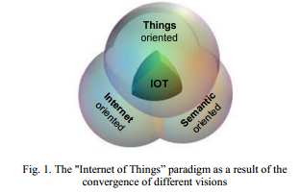
Adopting the perspective outlined above, Table 1 presents several definitions of “Internet of Things”.
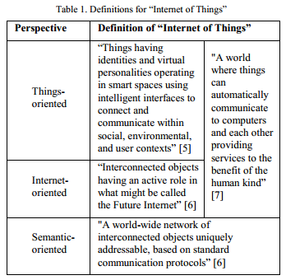
In fact, IoT can be simply considered as a shift in paradigm. “From anytime, anyplace connectivity for anyone, we will now have connectivity for anything”. Even though a standardized definition of the “Internet of Things” does not exist, most of the definitions related to this vision have much in common, such as :
- the ubiquitous nature of connectivity,
- the global identification of every thing,
- the ability of each thing to send and receive data across the Internet or the private network they are connected into.
Depending on the nature of things, different ways of connecting them to IoT will be used. Three
major technology areas related to IoT offer three major options, as we can see in Table 2.
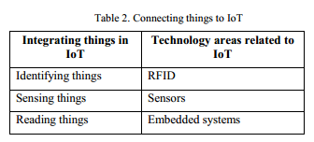

Things in IoT should be identified by at least one unique way of identification for the capability of addressing and communicating with each other and verifying their identities. In many research papers and reports, if the "thing" is identified, it is called "object". RFID technologies, shortly described in section 3, can be used to identify objects in IoT. In fact, RFID is viewed as a key enabler of the Internet of Things. Accordingly, a robot can become a part of the Internet of Things (as a thing), as we can see in the proposed system.
B. IoT Applications
IoT applications will be used in a wide range of innovative areas, with the main fields of application as illustrated in Fig. 2. The CERPT-IoT [12] describes these application domains
with indicative examples (Table 3). Also, Beecham Research depicts a diagram (Fig. 3) that represents the IoT ecosystem in different industry sectors, such as, energy, healthcare, industrial, transportation, retail, etc. But the widespread adoption of the Internet of Things takes time and numerous reports identify business, policy and technical challenges that need to be tackled. Table 4 presents some of these challenges.

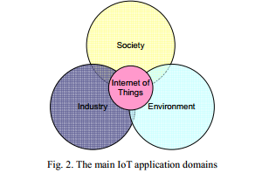
C. IoT Platforms
Currently, bridging the gap between the real and the virtual world is possible through developed IoT platforms. Next we shortly introduce some of these IoT platforms. Pachube) was published as an open real-time data infrastructure platform for the IoT, which manages millions of data points per day from thousands of individuals, organizations and companies around the world. Pachube’s motto was “patching the planet”. For example, Pachube was used as a tool for understanding the environment, for getting feeds from the stuff that has an electronic pulse and the means to communicate it to better understand what’s going on around the world. Thus, one of the most dramatic demonstrations of Pachube’s potential was visualizations of data that show
radiation levels around the Japan and especially near the nuclear reactor. Now, Pachube.com has evolved into Cosm.com.

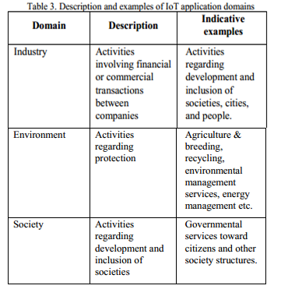
SenseTale is an Internet of Things application that aggregates data from different sensors embedded in physical objects, mobile devices, electronic appliances and the environment. The live data coming from a sensor is used to create a story that can be shared with friends/family/external users through a social platform.

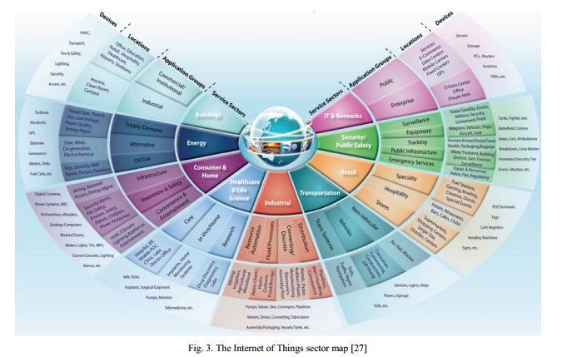

- PROPOSED SYSTEM
In the proposed system we present an IoT-based approach which is capable of maintaining desired wireless communication coverage among neighboring robots. here we consider the connection of the robot to the Internet of Things. The proposed robot has several sensors like infra-red (IR) sensors (that can be used, for example, to identify obstacles in the robot path), temperature sensor, light intensity sensor and smoke sensor which will measure the corresponding parameters.

In the Internet of Things this robot can connect as a thing. Thus, it can establish connections to other things over the Internet, either as a source of information and/or as a consumer. As an information consumer, the robot gains access to important information which it can gather in order to achieve certain tasks. Connecting robot to IoT as a source of information can considerably enhance, for example, the human-robot collaboration.
The considered robot can be connected to Internet of Things, either in an active or in a passive mode. In a passive mode, the robot is not connected to the Internet, but can be uniquely identified through an RFID tag. Other Internet connected things with RFID reading capabilities can identify this robot and publish on IoT robot related information, e.g., robot localization information. In an active mode, the robot is connected to the Internet, allowing sending real-time information to the Internet.

In order to connect our robot to the Internet of Things, we consider two robotics an one IoT platform ThingSpeak. The block diagram of proposed system is as shown in the figure below.
Block Diagram:
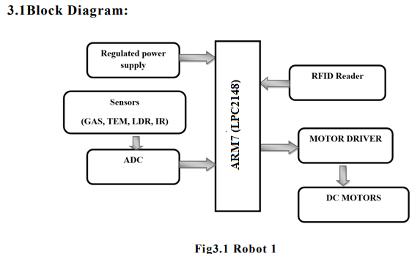
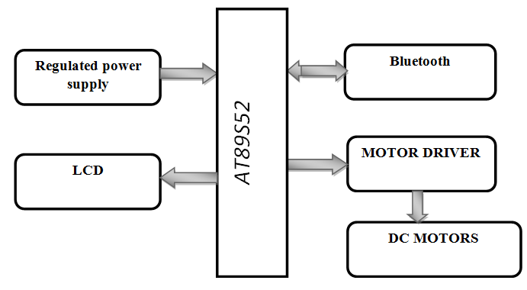
Fig3.2 Device node-2
WORKING:
In the proposed system we are developed the two industrial robots which will communicate each through IoT. Here
Robot-1 send the start and stop signals to robot-2 through IoT when it reaches to RFID tags placed at particular points.
Robot-1 continuously monitor and send the industrial parameters (gas, temp, humidity) and path condition details to robot -2 through IoT.
Robot-2 will take the decision according to information getting from robot-1 .
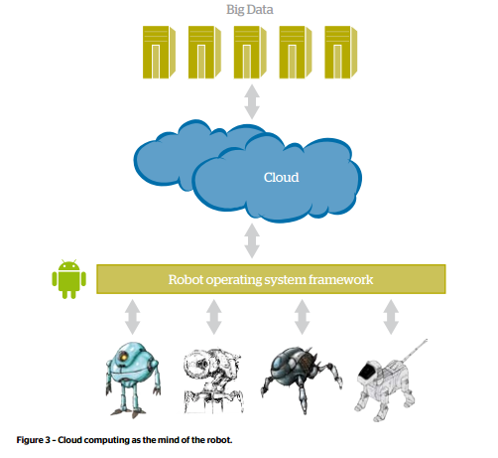
BLOCK DIAGRAM DESCRIPTION:
Here the proposed system consists of two sections. Here the section -1 consists of Raspberry pi , RFID reader, sensors (temperature, LDR, IR and smoke) and c motor units. Here the sensors will measure the corresponding parameter and send to the processor(raspberry pi 3), which will analze the sensor information and upload to the cloud. The section two consists of 89S52 microcontroller, Bluetooth module and motors,. Here the 89S52 microcontroller receive the sensor information from the cloud with the help of Bluetooth and android smart phone and displays on LCD, as well as it will process the sensor data and control the DC motors according to the received information.
SOFTWARE TOOLS:
Keil uVision IDE
Proteus
Thingspeakcloud
Embedded –C
ARM7:(LPC2148)
Figure2 shows complete hard ware setup for Driver safety system. In this proposed driver safety system used Raspberry Pi is a credit card sized single board computer developed in UK by the Raspberry Pi foundation. This Raspberry Pi has a Broadcom BCM2835 system on chip, which includes an sARM1176JZF-S 700 MHz processor, video core IV GPU, and originally shipped with 512 megabytes of RAM. It used only SD card for booting and longtime storage.

- Temperature Sensor
LM35 IC gives output voltage linearly proportional to centigrade temperature. The LM35 is rated to operate over a −55°C to +150°C temperature range. The temperature sensor has three terminals as shown in Fig.2. The data pin is connected to the chanel-3 of the inbuilt ADC using port pin P0.30. The general equation used to convert output voltage to temperature is T (oC) =Vout*(100o C/Vcc).
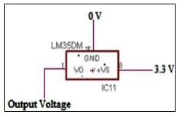
Fig.3 LM35 Temperature sensor

- MQ-2
gas sensor which detect gas leakage in industries and it suitable for detecting of LPG, iso-butane and propane it also detect cooking fumes and cigarette smoke. MQ-2 has six pin, four of them are used to fetch signals and other 2 are used for providing heating current.
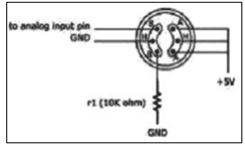
Fig.4 Gas sensor
- IR Sensor
IR detectors are specially filtered for Infrared light; they are not good at detecting visible light. IR detectors are digital out - either they detect 38KHz IR signal and output low (0V) or they do not detect any and output high (5V). When an object is close to the sensor, the light from the LED reflects off the object and into the light sensor. This results in a large jump in the intensity, and considered as object detected. When the object is far away from the sensor there is no reflection of back light hence it give high output.
- Light sensor
The light sensor is extremely sensitive in visible light range. With the light sensor attached to the system when the surrounding natural lights are low, it displays the digital values.
- RFID:
Radio Frequency Identification (RFID) is an IT system that transmits signals without the presence of physical gadgets in wireless communication. It is categorized under automatic identification technology, which is well established protocol. The working of an RFID system is very simple. The system utilizes tags that are attached to various components to be tracked. The tags store data and information concerning the details of the product of things to be traced. The reader reads the radio frequency and identifies the tags. The antenna provides the means for the integrated circuit to transmit its information to the reader. There are two types of RFID categories, active and passive tags. The tags that do not utilize power are referred to as passive and they are driven by an antenna that enables the tag to receive electromagnetic waves from a reader. On the contrary, active tags rely on power and they have inbuilt power sources that enable it to send and receive signals from RFID reader. RFID range depends on transmit power; receive sensitivity and efficiency, antenna, frequency, tag orientations, surroundings. Typically, the RFID range is from a few centimeters to over hundred meters. FID reader uses frequency 125 KHz with a range of 10 cm.

- RESULT ANALYSYS
In this proposed system, we implemented a IoT-based smart connectivity scheme to maintain global connectivity among multiple IoRT robots. The proposed approach is tried to capture the trade-off between network coverage and communication quality expressed as RSSI level. The proposed algorithms allow the whole IoRT robot network converges to the desired distance, and hence the desired communication quality. Through extensive simulation we showed that our approach outperform in terms of traveled distance and convergence time 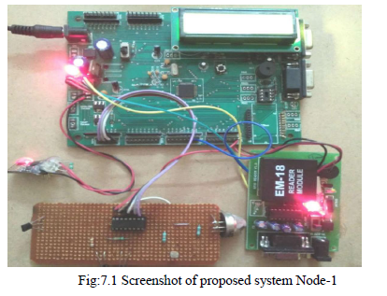
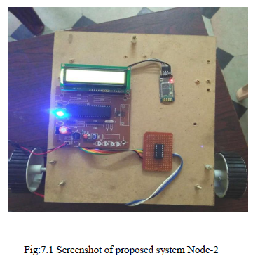
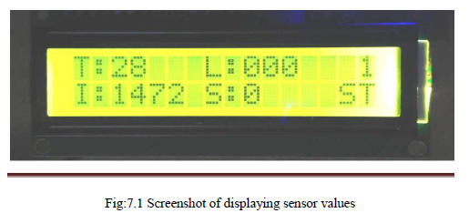
CONCLUSSION AND FUTURE SCOPE
In this proposed system, we implemented a IoT-based Intelligent robotic control scheme to maintain global connectivity among multiple IoRT robots. The proposed approach is tried to capture the trade-off between network coverage and communication quality expressed as RSSI level. The proposed algorithmsallow the whole IoRT robot network converges to the desired distance, and hence the desired communication quality. Through extensive simulation we showed that our approach outperform in terms of traveled distance and convergence time. Moreover, Our proposed methods always maintain the global connectivity throughout the simulation.

REFFERENCES:
[1] Ajith Abraham. Artificial neural networks. handbook of measuring system design, 2005.
[2] Gianluca Aloi, Luca Bedogni, Marco Di Felice, Valeria Loscri, Antonella Molinaro, Enrico Natalizio, Pasquale Pace, Giuseppe Ruggei, Angelo Trotta, and Nicola Roberto Zema. Stemnet: an evolutionary network architecture for smart and sustainable cities. Transactions on Emerging Telecommunications Technologies, 25(1):21–40, 2012.
[3] Tamio Arai, Enrico Pagello, and Lynne E Parker. Editorial: Advances in multi-robot systems. IEEE Transactions on robotics and automation, 18(5):655–661, 2002.
[4] Noury Bouraqadi, Serge Stinckwich, Victor Moraru, Arnaud Doniec, et al. Making networked robots connectivity-aware. In Robotics and
Automation, 2009. ICRA’09. IEEE International Conference on, pages 3502–3507. IEEE, 2009.
[5] Y Uny Cao, Alex S Fukunaga, and Andrew Kahng. Cooperative mobile robotics: Antecedents and directions. Autonomous robots, 4(1):7–27, 1997.
[6] Arnaud Casteigts, J´er´emie Albert, Serge Chaumette, Amiya Nayak, and Ivan Stojmenovic. Biconnecting a network of mobile robots using virtual angular forces. Computer Communications, 35(9):1038–1046, 2012.
[7] Jiming Chen, Shijian Li, and Youxian Sun. Novel deployment schemes for mobile sensor networks. Sensors, 7(11):2907–2919, 2007.
[8] Council. Internet of things council. http://www.theinternetofthings.eu. Accessed November 18, 2015.
[9] Miroslav Fiedler. Algebraic connectivity of graphs. Czechoslovak mathematical journal, 23(2):298–305, 1973.
[10] Marco Fiore. Ns-2.29 wireless update patch. http://perso.citi.insa-lyon.
fr/mfiore/research.html. Accessed November 19, 2015.

