IMPLEMENTATION OF HYBRID INVERTER INTERFACES IN DISTRIBUTED GENERATION UNDER DIFFERENT LOADING CONDITIONS

*L.DEEPIKA, ** prasad
*PG Scholar, Dept of EEE, Vikas Engineering College, Nunna; Krishna (Dt); A.P, India.
**Assistant Professor, Dept of EEE, Vikas Engineering College, Nunna; Krishna (Dt); A.P, India.

ABSTRACT: However existing distributed generation systems commonly use 3-leg inverters. In this project, the possibility of using a 4-leg inverter interface along with the existing units with 3-leg inverter is explored under various loads. Micro-grids (MG), mainly inverter based, are gaining more and more importance as they can accommodate various types of DGs effectively and for their superior power quality. A MG can be operated in two modes, grid connected and islanded mode. Each mode has its own control strategy. The general control philosophy within a micro grid is that sources must rely only on local information, yet must cooperate with other sources. To accomplish that goal, the proposed controller uses droop characteristics for active-power/frequency and reactive-power/voltage. The controller has been implemented in an actual micro grid that incorporated multiple sources. The main objective of the proposed controller is to inject a clean sinusoidal current to the grid, even in the presence of nonlinear/unbalanced loads and/or grid-voltage distortions. This is a novel way to mitigate the load unbalance by forming hybrid inverter interfaces instead of local unbalance compensators by using Matlab /Simulink. In this paper the performance of DG is tested for different loading conditions like balanced, unbalanced, linear and nonlinear conditions.
Key words-Distributed generation, 3-leg inverter, 4-leg inverter, unbalanced load.

- INTRODUCTION

In recent years, eco-friendly distributed generation systems (DGS) such as wind turbines, solar cells, and fuel cells are dramatically growing because they can fulfill the increasing demand of electric power due to the rapid growth of the economy and strict environmental regulations regarding greenhouse gas emissions. Generally, the DGSs are interconnected in parallel with the electric utility grid and provide maximum electric power to the grid. However, there are some areas (e.g., remote islands or villages) where the connection to the grid is expensive or impractical and then small scaled standalone DGSs are the only efficient and economical options. In such DGSs, depending on consumers “power demand, there are situations where some DGSs operate in parallel or

independently. In either case, a stable operation of each DGS unit is as important as the stability of the parallel operating DGSs in which the proper load sharing of each unit is one of main research issues since the voltage controller is commonly used in a single DGS unit or multipleDGS units. For this reason, the voltage controller design for a single DGS unit, which can guarantee a good voltage regulation under unbalanced and nonlinear loads, is an interesting topic in the field of the DGSs control.For the purpose of improving the quality of inverter output voltage, many researchers are working on designing the controllers for dc–ac power converters. In a robust controller is developed for balanced and unbalanced systems, which considers the uncertainties of the load parameters. However, nonlinear load is not fully addressed. In a repetitive control is used to regulate the UPS inverters. However, the slow response and lack
of the systematic method to stabilize the error dynamics with the repetitive control are being the main problems. In an alternative control strategy with a feed forward compensation component can significantly mitigate the effect of load disturbance and make the controller design simple. Nevertheless, the application of this method is mainly limited to balanced load conditions. In a current control technique based on the spatial repetitive control is applied to a single-phase inverter and it also improves the performance of the current controller by estimating the disturbances. Although this control can obtain good results under nonlinear load, it may not guarantee a good voltage tracking capacity for a three-phase system. In a robust servomechanism voltage controller and a discrete-time sliding mode current controller are presented to control a single distributed generation unit in a standalone mode which can operate well under a sudden load change, an unbalanced load, and a nonlinear load.

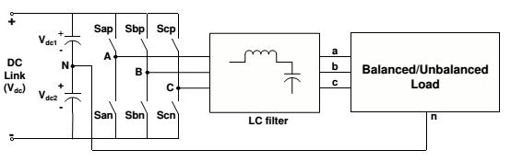
Fig.1: 3-leg inverter with split DC link capacitor.
Nevertheless this is the most popularly used topology for 3-phase, 4-wire DG system. Both the topologies fail while feeding a 3-phase, 4-wire unbalanced load. Hence additional unbalanced load compensators are usually provided near the unbalanced load end. However with the advent of 4-leg inverters (see Fig.3),it is possible to handle unbalanced loads without affecting terminal voltages [6], [7]. The load neutral can be connected to the center of fourth leg and zero sequence currents flowing through neutral can be controlled.
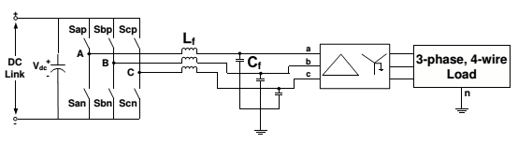
Fig.2: 3-leg inverter interface with -Y transformer.
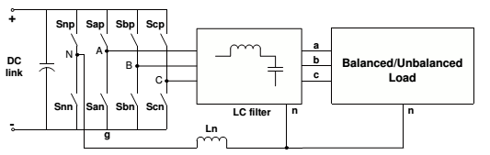
Fig.3: 4-leg inverter.

Advantages of 4-leg inverter interfaces are as follows:
- There are no ripples in DC link voltage when 4-leginverters cater to unbalanced or nonlinear loads. So there is no need of large DC link capacitors as is the case of3-leg split DC link topology.
- The 3-dimensional Space Vector Modulation (3-D SVM)technique enhances the utilization of DC link voltage [8].
- Presence of fourth neutral leg eliminates the requirement of bulky transformers for power evacuation (at least in small low voltage stand-alone DG systems).
The 4-leg inverters are widely used as active load compensators[9], [10]. The capability of using 4-leg inverter as an interface for stand-alone micro grid with unbalanced load is discussed in [11]. Its application to handle emergency mode for line interactive system is discussed in [12]. But all the existing DG systems are working with 3-leg inverter interfaces. However while expanding the existing system, the possibility of using4-leg inverter interface needs to be explored. This idea is addressed in detail in this paper. This is a novel way to mitigate the load unbalance by forming hybrid inverter interfaces instead of local unbalance compensators. The proposed DG system with 3-leg and 4-leg inverter interfaces is shown in Fig.4.
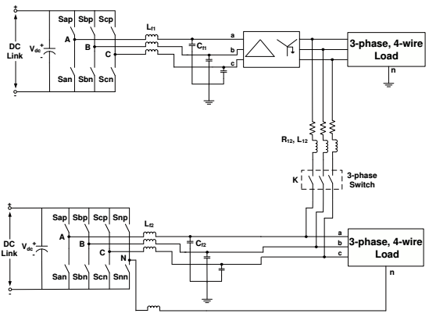
Fig.4: DG system with 3-leg and 4-leg inverter interfaces.

II. CONTROLLER DESIGN FOR 3-LEG AND 4-LEG INVERTERS
For the 3-leg inverter interface, 2-D SVM scheme [13] is implemented, whereas for the 4-leg inverter, 3-D SVM [8] is used. 3-D SVM is a superset of 2-D SVM technique. In both the SVM modulation techniques, DC link utilization is better as compared to other modulation techniques. Modulation index for 3D-SVM is defined as
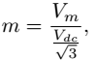 (1)
Where V_{m} is peak value of phase voltage and V_{dc} is the DC link voltage. For 230V rms phase voltage, Vm is 325V. With m = 1, DC link voltage required is 563V. But to take care of losses, it is maintained at 580V. For closed-loop design of each inverter, terminal voltages of inverters, load currents and capacitor currents are sensed. These are transformed into synchronous reference frame to form a decoupled closed-loop system. It is to be noted here that for 3-leg inverters, there are only q-axis and d-axis controllers (see Fig.5). This is because3-leg inverters have only two degrees of freedom (DOF). On the other hand, a 4-leg inverter has three DOFs and there are q-axis, d-axis and 0-axis controllers [14] (see Fig.6).
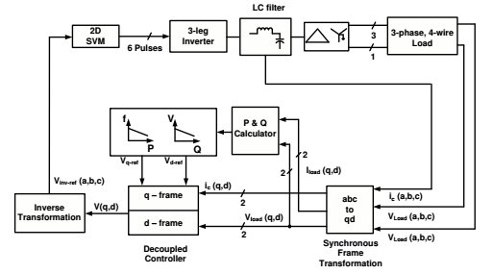
Fig.5: Closed-loop system for 3-leg inverter interfaced DG system.
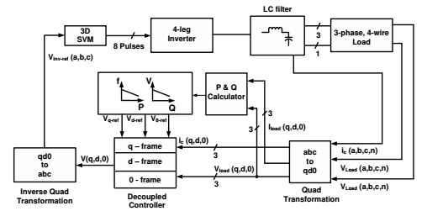
Fig. 6.Closed-loop system for 4-leg inverter interfaced DG system.
For decentralized operation, P -f and Q-V droop laws are applied. Thus there is no communication required between the two DG units. For generating references for inner voltage control loops, frequency and amplitude of voltages is generated by droop laws.
The transformation ratio of ∆-Y transformer used in 3-leginverter interfaced system is 1:1 for the sake of simplicity. In simulation, renewable energy source of DC link is replaced by3-phase diode bridge rectifier. All the simulations are carried out using MATLAB Simulink toolbox. Data for two inverters is given.
III. POWER FLOW ANALYSIS IN HYBRID DG SYSTEM
For understanding the power flow in interconnecting line, the single line diagram of DG system with hybrid inverter interfaces is shown in Fig.7. In this section, analysis of power flow in interconnecting line is carried out as given in [11].From the above study it is clear that for unbalanced load on
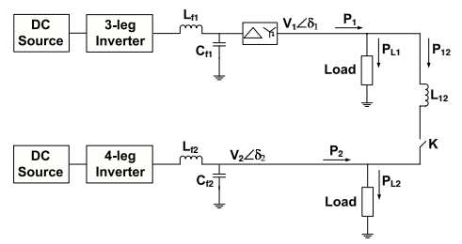
Fig.7: Distributed generation system with hybrid inverter interfaces.
4-leg inverter side, the negative and zero sequence components in terminal voltages of DG units are within acceptable limits specified by the above mentioned standards. The zero sequence currents never contribute to the power flow in interconnecting line [15]. The negative sequence component in terminal voltages is not negligible. Hence for calculating instantaneous power, positive and negative sequence components of currents as well as voltages are considered [11]. The 3-phase terminal voltages and interconnecting line currents are represented in the form of passers as:
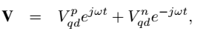 (2)
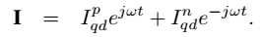 (3)
Here superscripts p and n denote respectively the positive and negative sequence component. The coefficients for all sequence components like$V_{qd}^{p}$, $I_{qd}^{p}$, etc., are vectors. In generalized way,they are represented as:
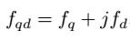 (4)
Instantaneous power in the interconnecting line is given as:
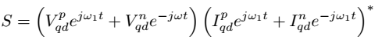 (5)
From this, the active and reactive power flow in the interconnecting line can be calculated as:
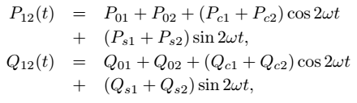 (6)
Where
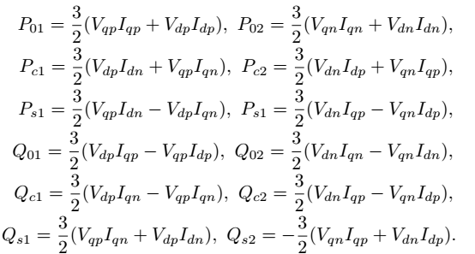
The dc components P01 and P02 contribute to the average power flow. In case of DG system formed using two 4-leginverters as given in [11], it is shown that and δ12 = δ1 − δ2 is the load angle between two units.
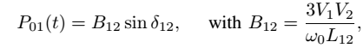 (7)
It is further shown in [11] that due to both 4-leg inverter interfaces, terminal voltages of DG units are almost balanced and average power P01 is due to positive sequence components of voltages and currents. Hence the power sharing between two units is as per droop laws. However in the proposed DG system with hybrid inverter interfaces, the average power is also due to negative sequence components of voltages and currents (P02)and this component does not allow P1 and P2 to follow exact sharing in proportion to the droop coefficients. This justifies the slight difference in power sharing after load unbalance. Also2ω oscillations in the power are due to the negative sequence components. This oscillating power shared by each inverter depends on the network parameters and output impedance of inverters.
In the present study only active power flow in hybrid system is studied and hence only resistive loads are considered. But Q-V droop laws can be applied for reactive power sharing. There active power flow will also show 2ω oscillations as derived in (7).
V. SIMULATION RESULTS

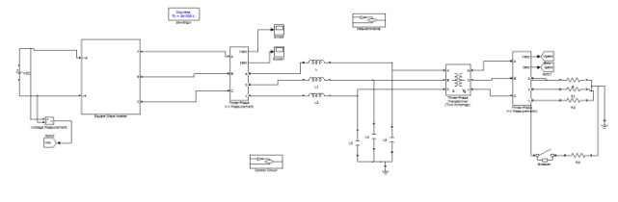
Fig 10 Matlab/simulation circuit of DG system with 3-leg and 4-leg inverter interfaces

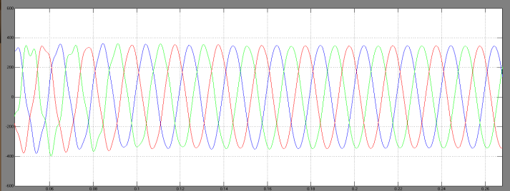
Fig 11 simulation wave form of Terminal voltages of stand-alone DG unit with 3-leg and 4-leg inverter interface with unbalance load

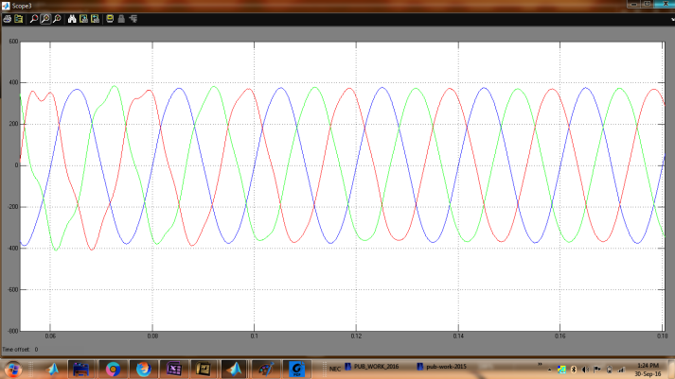
Fig 12 simulation wave form of Terminal voltages of stand-alone DG unit with 4-leg inverter interface with unbalance load

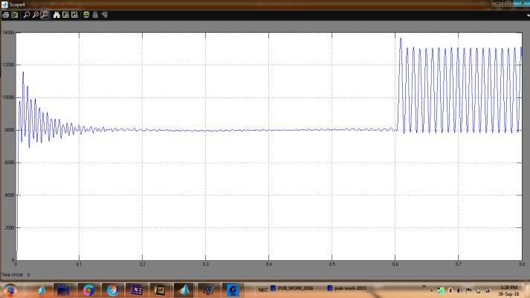

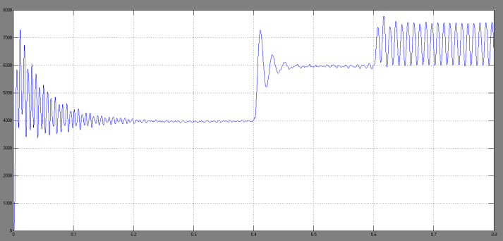
Fig 13 simulation wave form of Power sharing with unbalance on 3-leg inverter side.

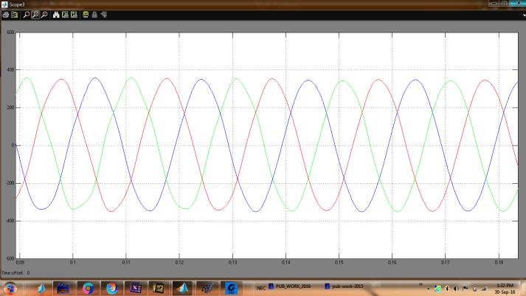
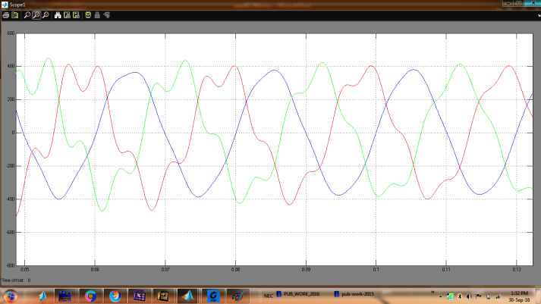
Fig 14 simulation wave form of Terminal voltages of DG units with unbalance on 3-leg inverter side.
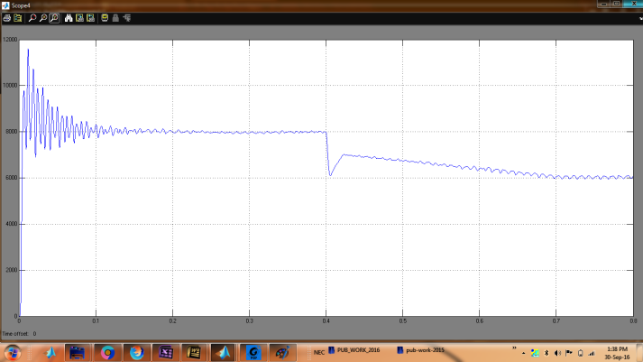

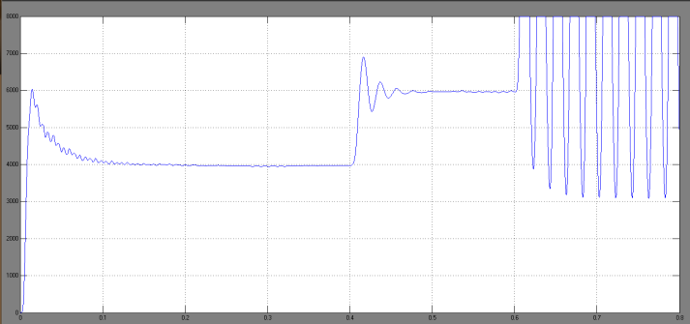
Fig 15 simulation wave form of Power sharing with unbalance on 4-leg inverter side

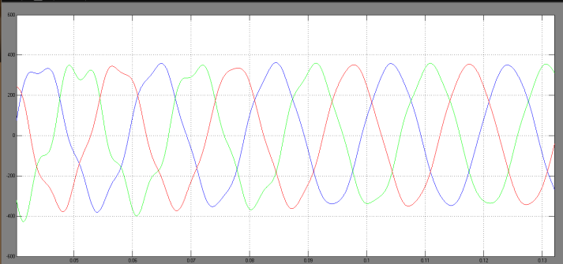

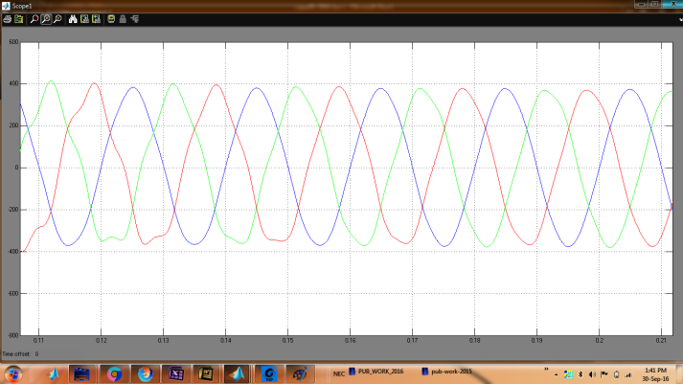
Fig 16 simulation wave form of Terminal voltages of DG units with unbalance on 4-leg inverter side.

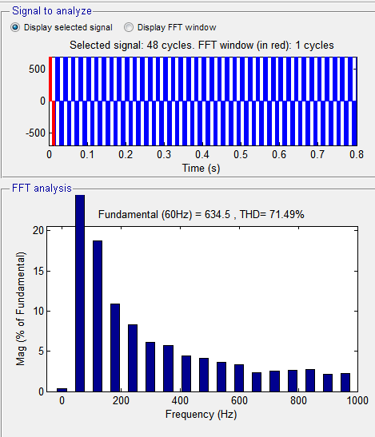

VI. CONCLUSION
This paper presents a novel method to improve the power quality at point of common coupling for a3-phase 4-wire DG system using PI controller and different load conditions for grid interfacing inverter. The grid interfacing inverter is effectively utilized for power conditioning. This approach eliminates the additional power conditioning equipment to improve power quality at PCC. The grid interfacing inverter with the proposed approach can be utilized to inject real power generation from RES to the grid, and operate as a shunt Active Power Filter (APF). The current unbalance, current harmonics and load reactive power, due to unbalanced and non-linear load connected to the PCC, are compensated effectively such that the grid side currents are always maintained as balanced and sinusoidal at unity power factor. Moreover, the load neutral current is prevented from flowing into the grid side by compensating it locally from the fourth leg of inverter. When the power generated from RES is more than the total load power demand, the grid-interfacing inverter with the proposed control approach not only fulfils the total load active and reactive power demand (with harmonic compensation)but also delivers the excess generated sinusoidal active power to the grid at unity power factor. The settling of the system is improved hence proposed load conditions of micro grid has fast response, high accuracy of tracking the DC-voltage reference, and strong robustness to load sudden variations.
REFERENCES
[1] M. Dai, M. N. Marwali, and A. Keyhani, “A three-phase four wireinverter control technique for a single distributed generation unit inisland mode,” IEEE Transactions on Power Electronics, vol. 23, no. 1,pp. 322–330, 2008.
[2] S. El-Barbari and W. Hofmann, “Digital control of a four leg inverter forstandalone photovoltaic systems with unbalanced load,” inTwenty-sixthAnnual conference of IEEE,
IECON, (Nagoya, Japan), pp. 729–734,October 2000.
[3] X. Song, Y. Wang, W. Hu, and Z. Wang, “Three reference framecontrol scheme of 4-wire grid-connected inverter for microgrid underunbalanced grid voltage conditions,” inTwenty-Fourth Annual IEEEApplied Power Electronics Conference and Exposition, (Washington,USA), pp. 1301–1305, February 2009.
[4] M. N. Marwali and A. Keyhani, “Control of distributed generationsystems - Part I : voltages and currents control,” IEEE Transactionson Power Electronics, vol. 19, no. 6, pp. 1541–1550, 2004.
[5] M. N. Marwali and A. Keyhani, “Control of distributed generationsystems - Part II : load sharing control,”IEEE Transactions on PowerElectronics, vol. 19, no. 6, pp. 1551–1561, 2004.
[6] I. Vechiu, H. Camblong, G. Tapia, B. Dakyo, and O. Curea, “Control offour leg inverter for hybrid power system applications with unbalancedload,” Energy Conversion and Management, vol. 48, no. 7, pp. 2119–2128, 2007.
[7] I. Vechiu, O. Curea, and H. Camblong, “Transient operation of a fourleg inverter for autonomous applications with unbalanced load,” IEEETransactions on Power Electronics, vol. 25, pp. 399–407, February2010.
[8] R. Zhang, V. H. Prasad, D. Boroyevich, and F. C. Lee, “Threedimensional space vector modulation for four-leg voltage-source converters,” IEEE Transactions on Power Electronics, vol. 17, no. 3,pp. 314–326, 2002.
[9] R. R. Sawant and M. C. Chandorkar, “A multifunctional four-leg gridconnected compensator,”IEEE Transactions on Industry Applications,vol. 45, no. 1, pp. 249–259, 2009.
[10] A. Kouzou, H. A. Rub, M. O. Mahmoudi, M. S. Boucherit, andR. Knennel, “Four wire shunt active filter based on four-leg inverter,”in International Aegean Conference on Electric Machines and PowerElectronics &Electro motion, (Istanbul, Turkey), pp. 508–513, September 2011.
[11] D. Vyawahare and M. C. Chandorkar, “Power flow analysis in standalone 4-wire, 4-leg inverter microgrid with unbalanced loads,” inSixteenth European Conference on Power Electronics and ApplicationsEPE-ECCE, (Lappeenranta, Finland), pp. 1–10, August 2014.
[12] D. Vyawahare and M. C. Chandorkar, “Line interactive distributed 4-leg inverter system with unbalanced and nonlinear loads,” in IEEEInternational Conference on Power Electronics, Drives and EnergySystems (PEDES), (Mumbai, India), pp. 1–6, December 2014.
[13] M. P. Kazmierkowski, R. Krishnan, and F. Blaabjerg,Control in PowerElectronics: Selected Problems. USA: Academic Press, 2002.
[14] M. J. Ryan, R. D. Lorenz, and R. W. D. Doncker, “Modeling of multilegsine wave inverters: A geometric approach,” IEEE Transactions onIndustrial Electronics, vol. 46, no. 6, pp. 1183–1190, 1999.
[15] H. Saadat, Power System Analysis. USA: PSA Publishing, 2010.

