IMPLEMENTATION OF UWB ELLIPTICAL NOTCH ANTENNA FOR WIRELESS APPLICATIONS
K. KARTHIK^{&2}, M.KEERAVANI

¹Department of ECE, ANU College of Engineering & Technology, Guntur, AP, India
²Department of ECE, KKR & KSR Institute of Technology & Sciences, Vinjanampadu, Guntur, AP, India
³Department of ECE, RVR & JC College of Engineering, Chowdavaram, Guntur, AP, India
ABSTRACT.
In this work, design the Ultra Wide Band (UWB) elliptical notch antenna is designed and analysed for wireless applications. The proposed antenna covers the impedance bandwidth of 3-15 GHz frequency range with notch band of 6.4 GHz – 7.5 GHz (BW of 1.1 GHz). The antenna is designed on the FR4 substrate with dielectric constant of 4.4. The size of the designed antenna is 35 x 30 x 1.6 mm³. The design parameters for achieving optimal performance are investigated. The proposed antenna is good agreement in terms of return loss, VSWR and Radiation patterns.
Keywords. CPW, UWB, elliptical patch

INTRODUCTION
The Ultra wideband technology has gained momentum in the field of antenna research ever since the FCC has allocated a wide band of 7.5 GHz for unlicensed use [I]. The most challenging part of the UWB system is the design of the UWB antenna. The printed monopole antenna has drawn much attention over the years to UWB antenna designers for its compact size, easy integration with monolithic integrated circuits and simple fabrication.
Over the last decade, researchers and antenna designers have made tremendous effort to design UWB antennas with various bands-notched characteristics that have been reported in open literature. Several antennas are designed with one notched band [2-7], two [8-12] or three [13-15] notched bands. Various types of slots were etched from radiator or ground to obtain such notched bands [16]. In most of the work, the characteristics of the band notch were achieved when the effective length of the closed slots was about half of the guided wavelength calculated at the desired notch frequency.
There are some narrow bands that exist in the allocated wide bandwidth of the

UWB system and these bands are used for other communication systems for example RFID (6.6-7.1 GHz) band lead to electromagnetic interference with the UWB systems. So, it is essential to design UWB antenna with band notched characteristics that can reduce the interference with the other existing systems.

ANTENNA DESIGN
The proposed antenna designed on a Method of moment based Antenna Design Framework (ADF) software. Figure 1 shows the schematic diagram of the proposed antenna. the antenna is structured as a Elliptical shape radiator fed with CPW (coplanar wave guide feed). An elliptical slot with long diameter a1 and short diameter b1 is etched on the radiating elliptical patch of long diameter a and short diameter b for getting notch characteristics.
The proposed antenna is printed on an FR4 microwave dielectric substrate with thickness of 1.6 mm and a dielectric permittivity is 4.4. The major parameters controlling the UWB antenna bandwidth. notch band and affecting its performance are optimized using the EM simulators. The final optimal dimensions are given in Table 1. The overall size of the antenna is 30 mm x 30 mm.

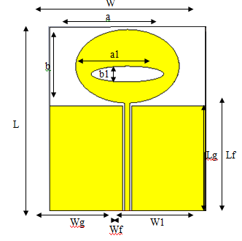
Fig.1. Proposed antenna
Table 1. The optimized dimensions of the proposed antenna
S.No | Parameter | Dimension (mm)
1 | L (length of the substrate) | 35
2 | W (width of the substrate) | 30
3 | Lg (Length of the ground) | 20
4 | Wg (Width of the ground) | 14.1
5 | Lf (Length of the feed) | 20.5
6 | Wf (width of the feed) | 1
7 | a (elliptical patch width) | 10
8 | b (elliptical patch length) | 7
9 | a1 (inner elliptical patch width) | 7
10 | b1 (inner elliptical patch length) | 1.5
11 | W1( gap and ground width) | 14.5

RESULTS AND ANALYSIS
Based on the optimized parameters the proposed antenna is designed. The simulated return loss is shown in the fig 2. The return loss shows the below -10 db from the frequency 3-6.4 GHz and 7.3 GHz to 15 GHz. The proposed antenna gives the good notch band of operating frequency 6.4 GHz – 7.3 GHz which covers the whole RFID frequency from 6.6 GHz -7.1 GHz. The simulated result of VSWR satisfies a less than 2 over the interested frequency band shown in fig 3. The radiation patterns (3D and 2D) for the proposed antenna is measured at frequencies of 5.5 GHz and 12 GHz from fig 4-7. The simulated radiation patterns are giving the almost omni directional patterns at the UWB range.
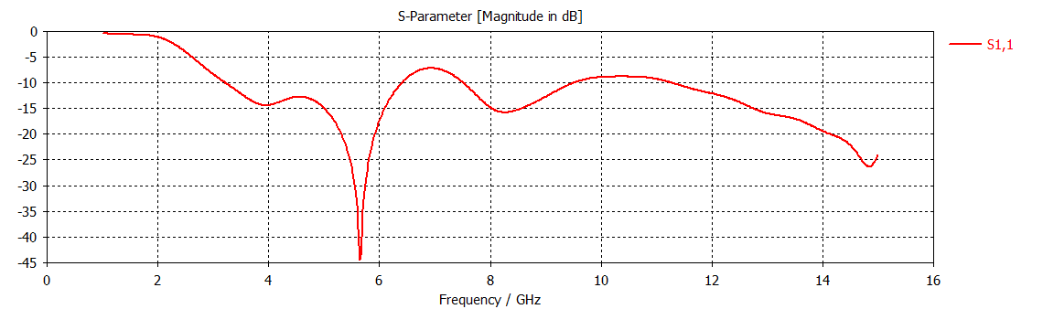
Fig.2. Return loss plot
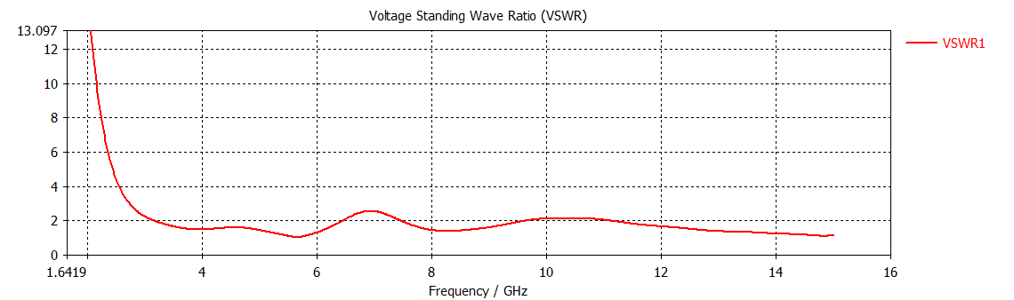
Fig.3. VSWR plot
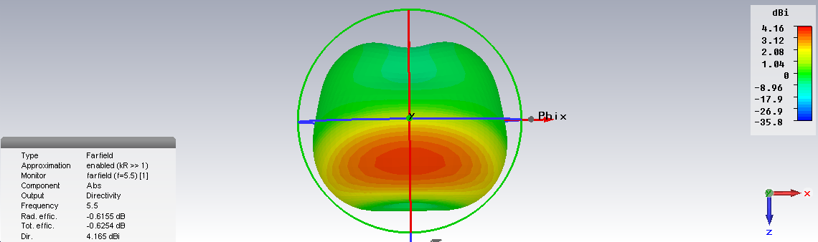
Fig.4.3D radiation pattern at 5.5 GHz

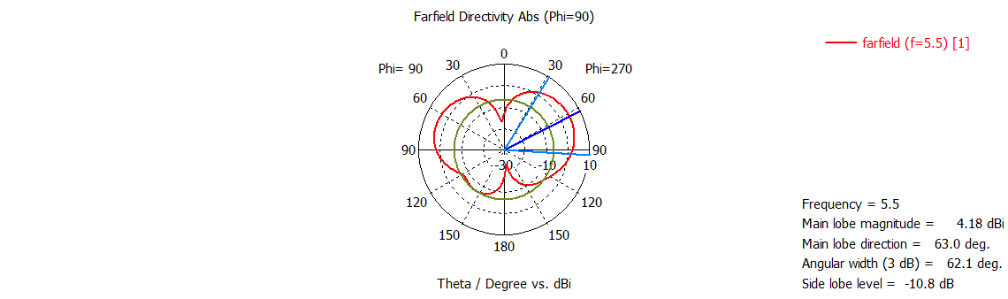
Fig.5. 2D radiation pattern at 5.5 GHz

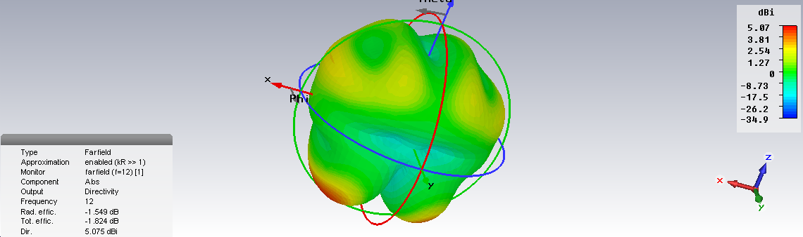
Fig.6. 3D radiation pattern at 12 GHz
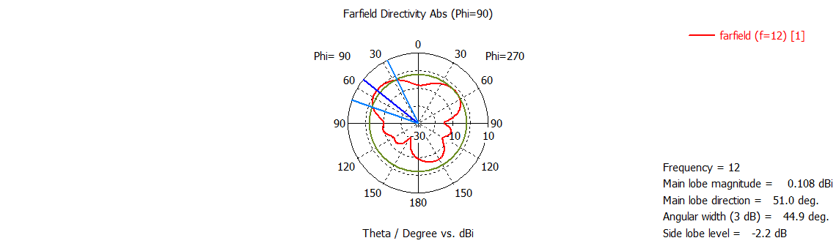
Fig.7. 2D radiation pattern at 12 GHz
CONCLUSION
The elliptical patch with single notch antenna fed by CPW for UWB is presented in this paper. The performance in terms of the Reflection coefficient, VSWR and radiation patterns are investigated in this work. The major parameters affecting the antenna performance have been analyzed. The antenna has also been confirmed to be nearly omni-directional over the entire bandwidth. Proposed antenna will get the good notch band operating at RFID frequency. besides, these features the antenna have a simple structure with small size, which is beneficial for system integration such as Wireless applications.
REFERENCES
I. Federal Communications Commission (FCC), Washington, DC, "First report and order in the matter of revision of Part 15 of the Commission's rules regarding uwb transmission Systems ".
2. Y. J. Cho, K. H. Kim, D. H. Choi, S. S. Lee, and S. O. Park, "A miniature UWB planar monopole antenna with 5-0Hz bandrejection filter and the time-domain characteristics," IEEE Trans. Antennas Propag., vol. 54, no. 5, pp. 1453-1460, May 2006.
3. C.Y.Hong, C.W. Ling, I. Y. Tam, and S. J. Chung, "Design of a planar ultrawideband antenna with a new band-notch structure," IEEE Trans. Antennas Propag., vol. 55, no. 12, pp. 3391-3397, Dec. 2007.
4. T. P. Vuong, A. Ghiotto, Y. Duroc, and S. Tedjini, "Design and characteristics of a small U-slotted planar antenna for IR-UWB," Microw. Opt. Technol. Lett., vol. 49, no. 7, pp. 1727-1731,2007.
5. Q. X. Chu and Y. Y. Yang, "3.5/5.5 GHz dual band-notch ultrawideband antenna," Electron. Lett., vol. 44, no. 3, pp. 172-174, 2008 .
6. K G. Thomas and M. Sreenivasan, "A simple ultrawideband planar rectangular printed antenna with band dispensation," IEEE Trans. Antennas Propag., vol. 58, no. I, pp. 27-34, Jan. 2010.
7. H.W. Liu, C. H. Ku, T. S.Wang, and C. F. Yang, "Compact monopole antenna with band-notched characteristic for UWB applications," IEEE Antennas Wireless Propag. Lett., vol. 9, pp. 397-400,2010.
8. M. Abdollahvand, G. Dadashzadeh, and D. Mostafa, "Compact dual band-notched printed monopole antenna for UWB application," IEEE Antennas Wireless Propag. Lett., vol. 9, pp.
1148-1151,2010.
9. M. M. S. Taheri,H. R.Hassani, and S. M. A. Nezhad, "Compact printed coplanar waveguide-fed ultra-wideband antenna with multiple notched bands," Microw. Opt. Techno!. Lett., vol. 54, no . 9,pp. 2121-2126,2012.
10. Zhu, F., S.-C. S. Gao, A. T. S. Ho, C. H. See, R. A. AbdAlhameed, J. Li, and J.-D. Xu, "Design and analysis of planar ultra-wideband antenna with dual band-notched function," Progress In Electromagnetics Research, Vol. 127,523-536,2012.
11. Azim, R., M. T. Islam, J. S. Mandeep, and A. T. Mobashsher, "A planar circular ring ultra-wideband antenna with dual bandnotched characteristics," Journal oj Electromagnetic Waves and Applications, Vol. 26, Nos. 14-15,2022-2032,2012.
12. Zhang, S.-M., F.-S. Zhang, W.-Z. Li, T. Quan, and H.-Y. Wu, "A compact UWB monopole antenna with WiMAX and WLAN band rejections," Progress In Electromagnetics Research Letters, Vol. 31,159-168,2012.
13. Li, G., H. Zhai, T. Li, X. Y. Ma, and C.-H. Liang, "Design of a compact UWB antenna integrated with GSM/WCDMAlWLAN bands," Progress In Electromagnetics Research, Vol. 136, 409- 419,2013.
14. Zi-Han Wu, Feng Wei, Xiao-Wei Shi, and Wen-Tao Li , "A Compact quad band-notched uwb monopole antenna loaded one lateral I-shaped slot," Progress In Electromagnetics Research, Vol. 139,303-315,2013
15. R. Azim and M. T. Islam, "Compact planar uwb antenna with band notch characteristics for wlan and dsrc," Progress In Electromagnetics Research, Vol. 133,391-406,2013.
16. Satyabrata Maiti, Abhik Gorai and Rowdra Ghatak, " A CPW fed UWB Antenna with Triple Band Notch Characteristics using Multiple Fractal Slots ", National ConJerence on Materials, Devices and Circuits in Communication Technology, 2014.

